1-Write the correct word under the pictures :-
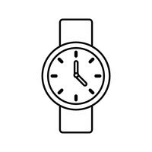 | 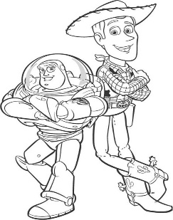 | 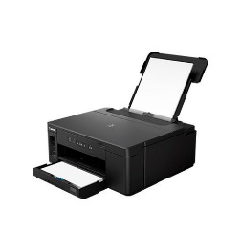 |  |  | 
Radio – wristwatch – credit card – printer – stove – toy story

2/ Choose the correct answer :-
1-( Have – Has ) you been to France ?
2- I ( was – were ) there two years ago .
3- ( How long – How many ) have you played football ?

3/Use since / for :-
Hameed has had the same Tv _________15 years .
My friend haven’t visited me ____________my graduation

4/Match the words with its meaning :-

1-Settle down ( ) I haven’t seen you for a long time .
2-Long time no see ( ) get married .
3-Miniature ( ) away of doing thing .
4-Technique ( ) a small modal .

5/ Complete the change into passive form :-

Millions of people use the internet

The internet ____________________by _____________

6/ Change the verbs to past tense :-

Invent _____________
Put ___________
Keep _________

