**SG.6 Revision U. 8 Drive Slowly**

**Grammar**

1. **Choose :**

* **1- You should ( drive – driving – driven ) carefully .**
* **2- you must ( stop- stops- stopped) at the traffic light .**
* **3- You should drive ( careful – caring – carefully )**
* **4- Sara is a quick girl. she speaks ( quick – quickly – quicker)**
* **5- Will you ( make – makes – making ) me some coffee ?**
* **6-( go – goes – going ) to your school .**
* **7- My mother asked me (to help – to helping – help ) her in cleaning**
* **8- Could you help me ? ( refusing ) ( of course – sure –sorry I can't )**
* **B) Correct :**
* **1- He drives fastly . fast**
* **2 -He plays good . well**
* **3- Don’t driving quickly . drive**
* **C) Do as shown between brackets :**
* **1- You stop at traffic light . You must stop at traffic light. (use must )**
* **2 - put on the seatbelt . ( Report the command )**
* **My father asked me . to put on the seat belt .**
* **3- Fill up the gas tank. can you fill up the gas tank ? ( Make a request )**

**Vocabulary :**

**D) Match the word with opposite :**

|  |  |  |
| --- | --- | --- |
| 1. **Slowly** | **2** | **Carelessly** |
| 1. **carefully** | **3** | **dangerously** |
| 1. **safely** | **1** | **quickly** |

**E) Match word with meaning :**

|  |  |  |
| --- | --- | --- |
| 1. **investigate** | **2** | **General direction** |
| 1. **trend** | **3** | **Habits** |
| 1. **custom** | **1** | **Search or study** |

**U.8 Drive slowly**

**F ) Complete each sentence with the correct adverb : ( hard- dangerously – aggressively )**

1. **Omar is an angry man , he screams and shouts . He drives very …aggressively………………**
2. **Tariq caused many accidents by driving …dangerously …………..**
3. **Khalid hasn’t passed driving test yet , but he is trying very ……hard ………..**

**G ) Write the correct word under the picture :**

**( danger – seatbelt – No parking – gas tank - steering wheel – No entry )**

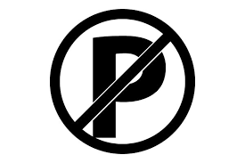 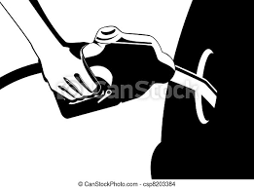 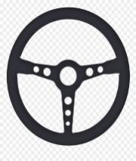 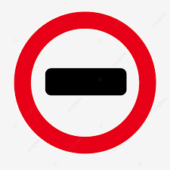 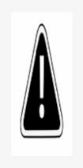 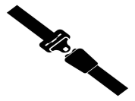

**No parking gas tank steering wheel No entry danger seatbelt**

**Best Wishes : T. Mayadh F Abohamad**