اختبار الفصل الدراسي الثاني النهائي الدور الأول للصف الثالث متوسط
المادة: لغة إنجليزية الزمن: ساعة ونصف
اسم الطالبة رباعيا: -------------------------------------------- رقم الجلوس: ----------------

6
- Composition:
Write a paragraph about Kingdom of Saudi Arabia

(know – country - area - kilometers – located – south west – capital – Muslim – natural – resources – proud)

-----------------------------------------------------

------------------------------------------------------------------------------------------------------

------------------------------------------------------------------------------------------------------

------------------------------------------------------------------------------------------------------

------------------------------------------------------------------------------------------------------

------------------------------------------------------------------------------------------------------

------------------------------------------------------------------------------------------------------

------------------------------------------------------------------------------------------------------

-1-

2-Reading Comprehension

6
Read the following passage and answer the questions:

People like going on holidays. Holidays give us a lot of fun. There are a lot pf places which you can visit on holidays. Some people like going to the beach to swim, play games or sit in the sun. Some like going to the mountains when there is now. There are people who love going to a river or a lake for fishing. Many people go camping in the desert. Some people think it is good to relax at home reading or watching TV.
- Choose the correct answer:
- What is the best title of the story?
a.Beach b.Fishing c.Holidays d.Camping
2- People like going on:
a.bus b.car c.taxi d.holidays
3-The word Some in line (3) refers to:
a.games b.mountains c.people d.holidays
4-Some people go to the beach to ………
a.swim b.sleep c.read d.buy books

- Answer the following questions:

- Where do people go camping?
…………………………………………………………….
2-Why do people like going to the beach?
………………………………………………………………

-2-

3-Grammar

7
A) Circle the right answer to fill in the blank:
1. We ------- friends since first grade.
has been have been been being
2.Trains are ……. Planes.
as expensive as as expensive most expensive expensive
3. Can you go out tonight? Sorry. I ……… . I have to study.
could can’t can none
4.You must …… at the traffic light.
stop stopping stops is stop
B)Do as shown between brackets:
1- Close the window. ( Change to negative )
------------------------------------------------------------------------
2-This old car is in good condition,……………..? ( Complete with tag question)
3-Are you coming to ………… party? (Write a / an / the )
4-Vocabulary

7
A.Choose the right answer:
1- A safe city has a low ….
crime rate cost of housing air quality transportation
2-Hanan needs paper for the ….
stove radio printer microwave

-3-
3-What do you use to make tea?
a teapot a fork a plate a spoon
B.Match the words:
1 | steering |  | board
2 | road |  | sign
3 | wind |  | wheel
4 | dash |  | shield
C.Write the correct word under each picture:
fan credit card traffic seatbelt
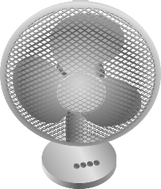 | 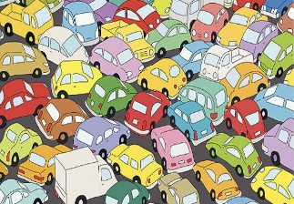  هذه الصورة بواسطة كاتب غير معروف مرخصة بالاسم CC BY-SA-NC | 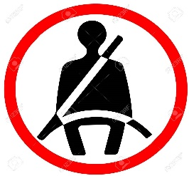  هذه الصورة بواسطة كاتب غير معروف مرخصة بالاسم CC BY-NC-ND | 

---------------------- ---------------------- ---------------------- ----------------------
5-Orthography

4
Choose the correct letter:
compu…..er  ( o – y – t ) | ph……ne  (o – a – t ) | spoo…..  ( w – n – v ) | t…..ain  ( r – n – s )
are……  (o – a – t ) | tic…..et  ( k – g – v ) | televisi…n  ( o – g – v ) | ….ark  ( c – p – m )

THE END GOOD LUCK
T.Nada Alwarthan

-4-

