**اختبار مادة اللغة الإنجليزية للصف الأول متوسط (الفترة الاولى)1433هــ**

اسم الطالبة : الصف:

**20**

**A) Write the correct word under each picture:**

**Vocabulary:**

**turn left – stove - sink - mirror - rug - closet ) (**

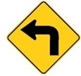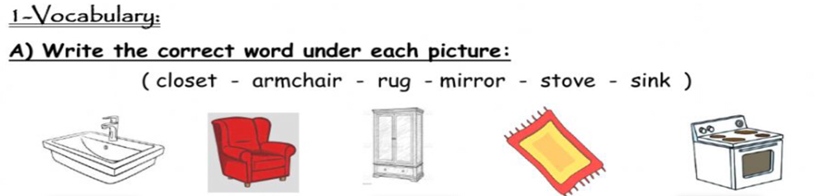

**B) Choose the best answer to fill in the blank in each question.**

1. **Is there a ____________ near here? I’m hungry.** 
   1. **airport b. gym c. restaurant**
2. **I buy vegetables from the ____________ on the corner of Main St. and Elm St.** 
   1. **supermarket b. bank c. subway station**
3. **I enjoy walking in the ____________ on Oak Street.** 
   1. **convenience store b. park c. bus stop**
4. **We can buy medicine from a ____________ .** 
   1. **bank b. pharmacy c. post office**
5. **The park __________________ .** 
   1. **it`s a place to sleep b. it`s a place to buy a book c. it`s a place to take a walk**
6. **Is there a place with many stores near here? Yes. There’s a ____________ in Al-Aalia.** 
   1. **mall b. store c. gym**

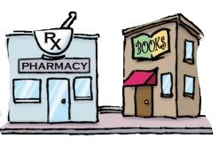**Grammar:**

**1. the pharmacy is _____________the bookstore.**

**a. near b. far from c. on**

**2) There ………… a sound system in the living room.**

**a. are b. is c. am**

**3) I can speak English …………. I can’t speak French.**

**a. but b. and c. or**

**4). Amal lives _________ Jeddah .**

**a. on b. near c. in**

**5). The bus stop is _________the corner.**

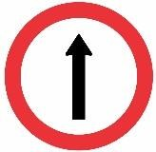 **a. under b. on c. in**

**6). _____________________.**

**a. Go straight b. Turn right c. Turn left**

**Orthography:**

**Choose the correct letter:**

1. **Brid..e. ( f - n - g )**
2. **Airpor… ( t - o - m )**

**Good luck T/Samia Al-Jehani**

1. **Sto….e. ( s - r - l )**