**SUPER GOAL 1 – 2ND TERM** YOUR MAME :………………………………………………………..

***Read the following text then answer the questions*Hello, my name is Mona . Welcom to my house! My house has five rooms.The first room is the living room .I like to watch TV in the living room. The next room is the kitchen. Sometimes I cook dinner in the kitchen. The dining room is next to the kitchen. I eat dinner with my family in the dining room. I also have a bathroom. The bathroom has a shower, toilete and sink. The last room is the bedroom. My bed is very comfortable. I sleep well in my bedroom.**

1-She like to watch TV in

bathroom



living room



2-Her bed is uncomfortable

True



False



3-She eats dinner with her

friend



family



4-She cooks dinner in the kitchen

True



False



_________________________________________________________________________________________

**GRAMMAR**

Choose the correct answer:

1. There ( is – are – in ) a nice bed .
2. I can speak English ( and – but – or ) I can't speak French.
3. I live ( on – in ) Jeddah .

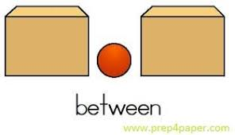

1. The ball is ( between – next to – on ) the boxes .

_________________________________________________________________________________

**Vocabulary**

1. You can't mess it means ( You are sure to see it - You aren't sure to see it).
2. Trust me means ( depend on me – believe me )

--------------------------------------------------------------------------------------------------------------------------------------------------------

**DICTATION**

1. Bedroo…… ( n – z – m ) 2- Ga….age ( s – k – r ) 3- Hea…h ( q – t – l )