Unit ( 8 ) What are you doing?

Name:………………………………………………….. Class: 1st Year

**1-Speaking:**

**Answer:**

**A) What are you doing?**

…………………………………………………………………………………………..………………………………………..

**B) What is she doing?**

…………………………………………………………………………………………..………………………………………..

**C) What are they doing?**

…………………………………………………………………………………………..………………………………………..

**D) Is he sleeping?**

…………………………………………………………………………………………..………………………………………..

**E) Are they studying?**

…………………………………………………………………………………………..………………………………………..

**2-Vocabulary:**

**A) Write the correct word under each picture:**

( writing - looking at - speaking - waiting - wearing - surfing )

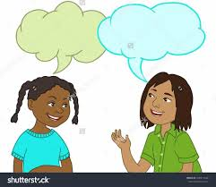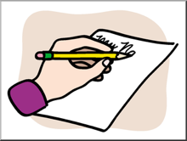

…………………… …………………. …………………. …………………. ………………….

**B) Complete the sentences with the words in the box:**

waiting - play - surfing - sleeping - some water - watching

1- I am ………………………………. the net.

2- Omar and Ahmad are ……………………………… for the bus.

3- We would like to ……………………………… computer games.

4- Lana is ……………………………… TV with her sister.

5- I'm thirsty. I would like ……………………………… .

**3-Grammar:**

**A) Choose:**

1- He ( am - is - are ) drinking coffee.

2- We ( am - is - are ) cleaning the class.

3- I ( am - is - are ) doing my homework.

4- Amal is ( play - plays - playing ) with her sister.

5- They ( am - is - are ) sleeping now.

6- ( Ali- I - Ali and Adel ) is driving the car.

7- I would like ( paint - to paint - paints ) with my friend.

8-What would ( you like - like you - like ) to eat?

**B) Fill in the Blank:**

**Write the present progressive of the verbs in parentheses to fill in the blank.**

1- My mother …………………………………………….. ( cook ) pasta.

2- You …………………………………………….. ( talk ) with your cousin.

3- We …………………………………………….. ( not play ) now.

4- The cat …………………………………………….. ( jump ) in the garden.

**C) Answer the questions:**

1- What are you drinking?

…………………………………………………………………………………………………………………………………………

2- Are you reading a book?

…………………………………………………………………………………………………………………………………………

3- What are you doing?

…………………………………………………………………………………………………………………………………………

4- What would you like to wear?

…………………………………………………………………………………………………………………………………………

5- Where would you like to eat?

…………………………………………………………………………………………………………………………………………

6- When would you like to go?

…………………………………………………………………………………………………………………………………………

7- Would you like to go out?

…………………………………………………………………………………………………………………………………………

**T. Manal Alammar**