Unit 1revision – What do you do ?

I- Grammar :

1-Simple Present Tense

We use simple present tense for :

1-things that you do every day : I cook dinner every evening.

The verb ending for it , he and she = (the -s ending)

But  **the present progressive for now :** I’m teaching now.

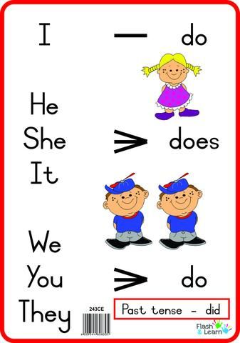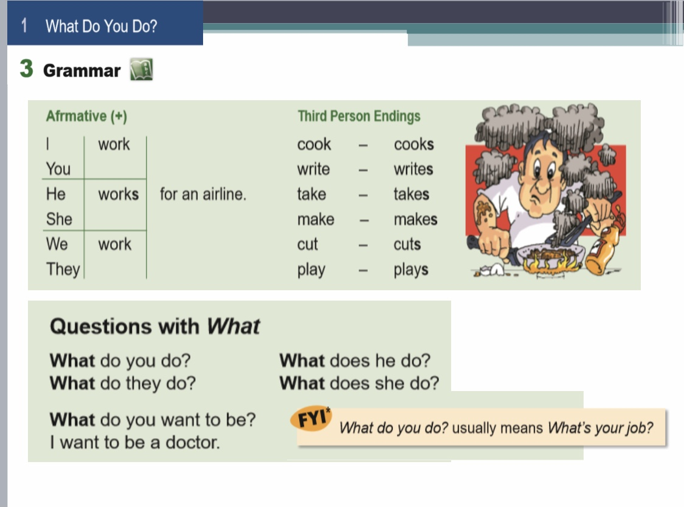

2-Questions with What

Question word + do/does + subject + main verb?

the main verb is always in the **base** form in the question.

What do you do? usually asks about a person’s job. It doesn’t ask about what the person is doing at that moment. That question is What are you doing?

**Choose the right answer :**

1. …………………………… does Adel do? He takes photos.

a-What b- Why c- Where

2. What are you doing ?

a- I sell clothes. B- I am writing my homework c- She teaches students

3. He ……………………….. food.

a-cook b-cooking c-cooks

4. They …………………. in a restaurant.

a-work b-works c-working

6. They ………………….. taxis.

a-drives b-drive c-driving

7. He …………………… magazines.

a-sell b-selling c-sells

8-What is she doing now ?

a-She is cleaning her room b- She is a doctor c-They are dancing

3-Why? = For what reason?

Because… = refers to a reason and answers the question Why?

So = refers to a result or consequence.

(result) (reason) He studies a lot, so he is a good student.

1. He’s interested in computers,………… he wants to design software.

a-so b-because c-Why?

2. We’re studying …………………..we have a test in history tomorrow.

a-So b-because c-Why?

3. He wants to be a carpenter……………… he likes to build houses.

a-so b-because c-Why?

4-…………………. does she want to be a chef ?

Because she likes to cook .

5-………………. Do you want to be flight attendant ?

Because I like to travel ant meet new people .

6. The car has a problem…………… the mechanic is checking it out.

a-so b-because c-What ?

II-Vocabulary :

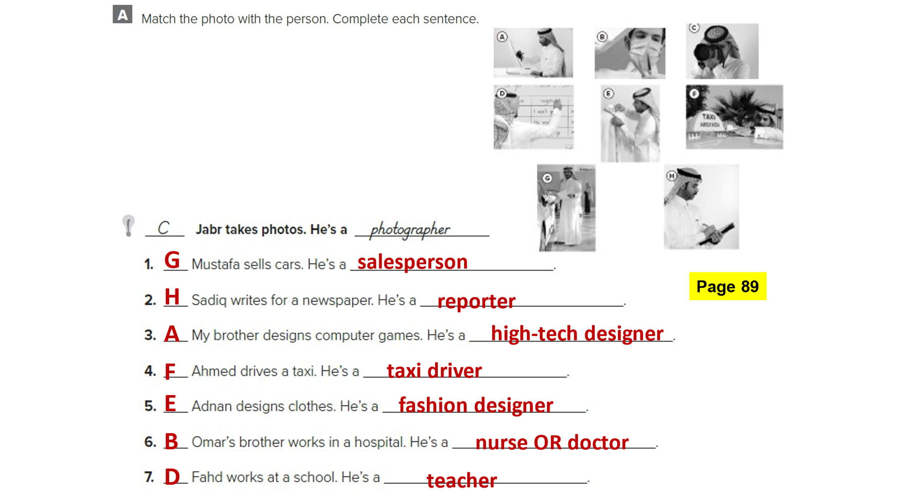

|  |  |
| --- | --- |
| The meaning | The word |
| announcement | 1-advertising |
| Air carrier | 2-airline |
| **A person Who works in construction. designs houses and other buildings.** | 3-architecture |
| Skill , creativity | 4-art |
| Create , plan | 5-design |
| Medical center | 6-clinic |
| Time to come | 7-future |
| Device ,appliances | 8-gadget |
| Work , career | 9-job |
| **A person who works in a workshop.** | 10-carpenter |
| **A person who works in a restaurant** | 11-chef |
| Chef | 12-cook |
| **A person who works in a hospital.** | 13-doctor |
| **A person who flight attendant. She works on an airplane.** | 14-flight attendant |
| journal | 15-newspaper |
| repairman | 16-mechanic |
| **A person who works in radio, television and online news station.** | 17-reporter |
| clerk | 18-salesperson |
| A person who teaches and learn students | 19-teacher |
| Business | 20-profession |
| A person who drives a bus | 21-bus driver |
| photographer | 22-cameraman |
| **A person who works in office** **in courtroom .** | 23-lawer |
| A person who works in a restaurant . | 24-waiter |
| A person who design websites | 25-website designer |
| Make into pieces | 26-cut |
| Excellent | 27-professional |
| Move in a car | 28-drive |
| Create , build | 29-make |
| See someone | 30-meet |
| Exchange an object for money | 31-sell |
| Trip or journey | 32-travel |
| concerned | 33-interested |