**Name: ……………………………….. Class 1/….. First Period Exam – Second semester**

---------

**Comprehension; Read the text and answer the questions.**

My name is Amal. I'm Saudi. I live in Madinah.

I'm fourteen years old. My email address is Amal@web.com.

My phone number is 555-310-998.

**A) choose the correct answer:**

1- Amal is from............ a) Oman b) Yemen c) Saudi Arabia

2- she lives in............ a) America b) Canada c) Madinah

3- she is...........years old a) eighteen b) fourteen c) nineteen

4- Her email address is........ a) hameed@web.com b) ali@web.com c) Amal@web.com

**A-Match the pictures to the correct word:**

**1.mall 2.rug 3.hotel 4.stove 5. sofa**

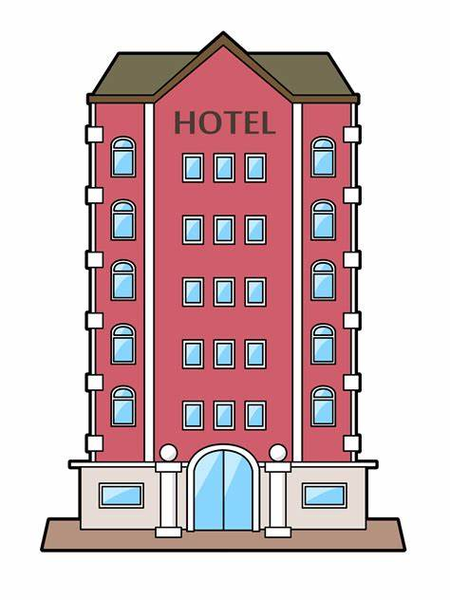





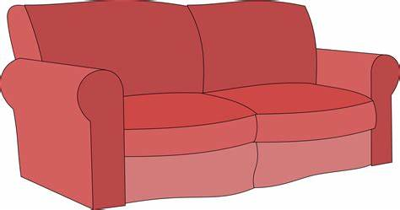



**.............…… …………….. …………… …..…..….….. ……………..**

**B- Choose:**

1-We live ( **in – on – for**) the twelfth floor.

2-Healthy food is ( **good – better – best** ) than fast food.

3-Ahmad is ( **tall – taller – tallest** ) than Ali.

4-( **Is – Am - Are** ) there curtain**s** in the kitchen?

5-We read ( **or – and – but** ) write in class.

**D-make a question then answer.**

1-There is a desk in the bedroom. ……………………………………………………….……?

**E-Choose the correct answer.**

1-The mouse is **( under – far from** )the table. 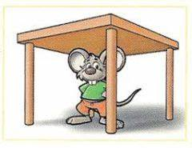

2-the fox is (**between – next to** ) the tree. 

**F-Unscramble the words:**

1. paml …………………… 
2. nkba ……………….… 

**G-Write the missing letters.**

1. .b---d ( **h – e– o** )

1. ch---ir ( **c – a – m** )

**GOOD LUCK**

**T/ Areej AlHausoni**