**Revision Unit 11 What time do you get up?**

**Name:……………………… Class: 1/..**

**☺ vocabulary**

1. Match the words with the correct pictures:

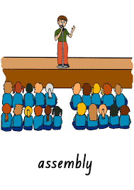 ( study – martial arts – uniform - assembly – get up )

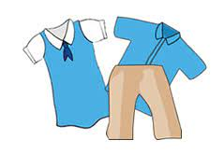 

……………….. ……………….. ……………….. ……………….. ………………..

B) Choose the correct answer:

( before – absolutely not – begin – after – put on – wake up)

1. They …………………………….. at 6 am. in the morning.
2. The activities…………………………….. at 10 pm.
3. The opposite of after is ……………………………..
4. She brushes her teeth ……………………………. lunch.
5. I ……………………………. my school uniform.
6. No way means …………………………….
7. Choose the ***odd*** word:
8. wake up – art - ride – play
9. morning – evening - before - afternoon

**☺ Grammar**

A) Choose the correct answer:

1. My friend goes to school ( in – at – on) 6:30am.
2. The party is ( in – at – on) the evening.
3. We never go shopping ( in – at – on) weekdays.
4. I go to work ( at – on – by) car .
5. He usually goes to school ( at – on – by) foot.
6. The boy always ( play – plays – playing) football in the park.
7. She ( reads – is reading – are reading) a story at the moment.
8. Look! they ( are swimming – is swimming – swim) in the pool.

**☺ Orthography**

1. Choose the correct letter:
2. ch…..ck ( r- n- e) 4- stu…..y (d- r- t)
3. bi…..e (k- m- d) 5- wo….. k (r- k- a)
4. ge….erator (s-m- n) 6- r…..de (i -t -e)

👍Good luck