**2nd Grade English Exam ( second Term ) for the first period ( Unit 6 )**

**Student’s name : ………………………………………………….. class : ……………………….**

1. **Read the following passage and answer the questions below:**

Food , exercise and sleep are keys to good health . Food keeps us strong and helps us grow . A young man needs more food than an old man . Boys usually eat more than girls . Exercise helps the muscles to keep strong and it is good for the circulation of the blood . Sleep and rest also necessary for a healthy life .

**A-**What are the keys to good health?

……………………………………………………………………………

**B- Choose :**

1. a young man need ( more – less – same ) food than an old man.
2. ( Food - exercise – sleep ) is necessary for a healthy life .

**C- Put ( √ ) or ( × ):**

1-Boys eat more than girls ( )

2-Sleep helps the muscles to keep strong and is good for the circulation of the blood ( )

3-Food keeps us strong and helps us grow ( )

1. Grammar :

**A - ( choose the correct answer ) :**

1. Where ( was – were – am ) the football game ?
2. They ( was – were – do ) at school
3. I ( go – went – going ) to my friend yesterday.
4. We ( ate – eat – eats ) at a restaurant last weekend.
5. We ( wasn’t – weren’t – not were ) invited in the party last night.
6. They ( played – plays – play ) the match yesterday.
7. The cake is ( very – extremely ) delicious .
8. It ( was – were – am ) hot last night.
9. Vocabulary :

**A -Choose the correct number from (A ) and write in ( B )**

**(A ) (B)**

|  |  |  |  |
| --- | --- | --- | --- |
|  |  | **That's too bad** | **1** |
| **To show you are sorry about something** |  | **You did?** | **2** |
| **To express surprise** |  | **Out of this world** | **3** |

**B - ( Write the correct word under the picture ) :**

Angry – robot - calligraphy - nervous - sleepy

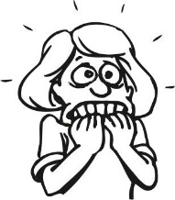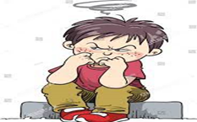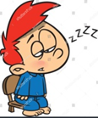



Good luck 😊 Teacher : Samia Al Saeed

-------------------------------

-------------------------------

-------------------------------

-------------------------------