Match the activities to the pictures.

1) do the cooking
2) do the shopping
3) vacuum / hoover the
carpet
4) clean the windows
5) iron the clothes
6) take out the rubbish
7) make the bed
8) mop the floor
9) water the plants
10) care a bout the baby
11) set / lay the table
12) clean the toilet
13) dust
14) walk the dog / take
the dog out
15) do the washing
16) cut the hedge
17) do the washing up
18) care about the pets
19) repair things
20) bake a cake
21) work in the garden

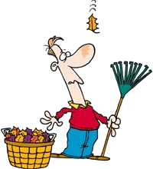 | 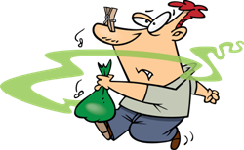 | 