**Grade : 2 Midterm Exam Unit 7 - 8**

**20**

Name:…………………………………………………………………

**A-Make a Suggestion and give a Respond:** (go bowling ) --------------------------

Accept ..…………………………………………… Refuse : ………………………………………………………………..

# Give examples of : ( cold – go shopping – clean the room – eyes )

Chores / ………………………………………. Illness / ……………………………………………

Activity/ . ………………..…………………… human body / ……………………….………..

**B-Match the problem with the advice :**

|  |  |  |
| --- | --- | --- |
| **Advise** | **-----** | **problem** |
| **You should go to the dentist** |  | 1. **We're very tired** |
| **You should take a rest** |  | 1. **I have a headache** |
| **You should take some Panadol**  **They should drink a worm liquids** |  | 1. **Ahmad has a toothache** 2. **They have a sore throat** |

**C-Choose the correct answer :**

1- You should ( prays - pray - prayed ) on time .

2- Why ( don’t - didn’t - doesn’t ) we clean the class ?

3- Let’s go (swimming- swims – swim )

4- I have to ( wash _ washing _ washes ) the dishes .

5- you (must – mustn't – should ) talk during the test .

**D-Write the correct word under the picture :**

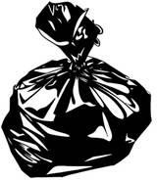صورة تحتوي على نص, قصاصة فنية

تم إنشاء الوصف تلقائياً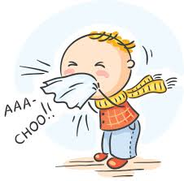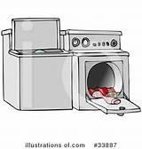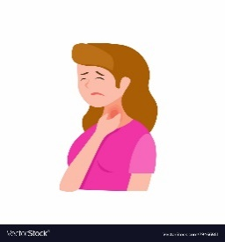( **flu - garbage - sore throat - laundry - stomachache**  )

………………….…. ……………………………. …………………….. ………………..…………. …………………..………