|  |  |  |  |
| --- | --- | --- | --- |
| المملكة العربية السعودية |  |  | اسم الطالب/ |
| وزارة التعليم | الصف/ الثاني متوسط |
| إدارة تعليم الرياض | الزمن / ساعة ونصف |
| مدرسة/ | المادة / لغة انجليزية |
| اسم المصحح / | الفصل الدراسي الأول 1444هـ |
| اسم المراجع / | الدور الأول |

**Q1 – Composition**

**Write a paragraph not less than 5 sentences about the following topic:**

**(Prince Mohammad bin Salman)**

**……………………………………………………………………………………………………………………………………………………………………………………………………………………………………………………………………………………………………………………………………………………………………………………………………………………………………………………………………………………………………………………………………………………**

**6**

**-------------------------------------------------------------------------------------------------------------**

**Q2 - Reading Comprehension:**

**Read the following passage and Write T or F at the end of each question/statement:**

**Police Department**

**Witness Report**

Incident: Motor Vehicle Accident

Witness: Larry Johnson

There was an accident at the corner of Main Street and Oak Street last night. A car crashed into *The Café.* The accident happened around 6:30 P.M. I saw it happen. I was at the bus stop across the street. A car drove through the intersection very fast. Someone started to walk across the street. The driver couldn’t stop. He turned and crashed into the café. Fortunately, no one was hurt. I was scared and worried about the people in the café. But everyone was OK. It was the driver’s fault. He was driving too fast.

**6**

1. The car drove too fast. { }
2. The driver was talking on his cell phone. { }
3. The driver was hurt. { }
4. The witness walked across the street. { }
5. The accident at the corner of main Street { }
6. The driver couldn’t stop. He turned and crashed into the café. { }

**Choose the correct answer:**

**7**

1- (Did– Does- Are) mike visit his grandmother last night?

2- (There is – There are – There was) 2 books on the bed.

3- Abdullah (mustn't – shouldn't – must) stop at the red traffic light.

4- Are these (your – yours - his) socks? There aren't mine.

5-Imad is (taller - tallest - tall) boy in the class.

6- What did you do (what - where - when) you had the flu? I stay in bed.

7- He (was- were- are) at home.

.---------------------------------------------------------------------- ----------------------------------

**7**

**Q4- Vocabulary**

**A- Mach:**

|  |  |  |  |
| --- | --- | --- | --- |
| 1 | witness |  | Where two roads cross |
| 2 | injury |  | Someone who saw an event |
| 3 | intersection |  | Hurt from an accident |

**B-Match the word with the suitable picture:**

**(** perfume - nose - shark - happy **)**

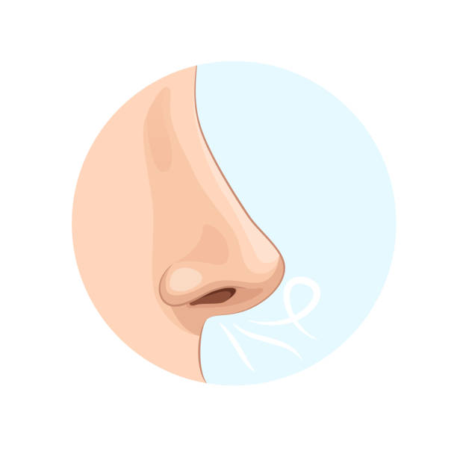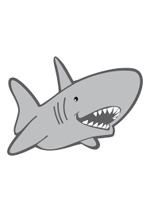 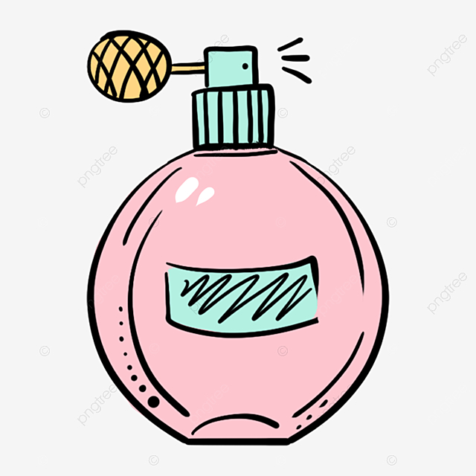

**………………..….. …………………………. …………………….. …………………….**

-----------------------------------------------------------------------------------------------------------------------------------

**4**

**Q5- Orthography “Spelling”**

**Choose the missing letters:**

1-Water e …….es (t – y - v) 2- Nec…. lace (t - k - b )

3- Run…..y nose (n - f- s ) 4- Mow the la…..n (w- h - k )

**Good luck**