1st English Language Test Mega Goal 1.2 ( A )
Name Class
----------------------------------------------------------------------------------------
1-A-Choose the correct answer :
1- 1. I saw ……………. In the mirror .
a-himself b-myself c-itself
2- Abdullah doesn't drive………….
a-care - b-careful –. C- carefully
3-I went to the doctor …………….. I was sick
a-because. b - so c- to
- You should …………. To lose weight .
a-trying. b- try c- tries .
- How ………….cars in the gallery ?.
A- many B- little c- much
6- How …………………..money have you got?
a-many b-much c-few
7 – I am happy ……………..
a- so am I b- so not I c- so can I
8- He put …………..sugar in his coffe .
- Few b- a little c- many
9- What do you do ( when – where – why) you have a cold?
10-The bank is ………. The hotel and restaurant .
- On b- between c- near

2-Choose the correct meaning:
11-anorexia …..means (a-loss of appetite b-fast food c- move out )
12- feeling down ….means (a- feeling depressed b- strong c-good day)
a-poke
b- cough
c-junk food
d-relax
3-- Match the picture with correct word

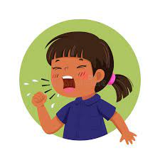
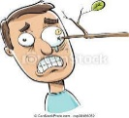
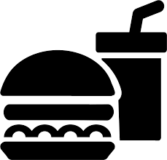

………….. ……….. …………. …………………..

4-Circle the odd word:
17- A- cut. B-next to c- burn. d- break.
18- A - sore throat B- flu. c-happy. d- cough

B-Do as shown in brackets:
-I don't like pizza. …………………………………… (Write suitable agreement response )
2- It getting late .it is time you went home . ( Write a sentence using had better )
……………………………………………………………………………………………………………………………………………………………………………………

