M.G 1.2 UNIT 1 & 2 A

Name……………………………………………………………. class..1\................

COMPERHENSION

One kind of boat is called a sailboat. A sailboat uses the wind to move. Wind makes a sailboat move in the water. The wind pushes the sailboat. Wind fills the sails. The sailboat moves when the wind blows. One kind of boat is called a motorboat. A motorboat uses a motor to move. The motor gives power to the boat. The motorboat moves when the motor is running. The motorboat makes a loud noise. One kind of boat is called a rowboat. A rowboat needs people to move it. People make a rowboat move in the water. People use oars to move a rowboat. Oars are long and flat. Oars go into the water. A rowboat moves when people use the oars. As you can see, there are many kinds of boats.

1) Which boat uses the wind to move?

A. a sailboat B. a rowboat C. a motorboat

2) Which boat makes a loud noise?

A. a sailboat B. a motorboat C. a rowboat

3) What is used to move a rowboat?

A. wind B. a motor C. oars

GRAMMAR

Choose the right answer:

|  |  |  |
| --- | --- | --- |
| B |  | A |
| a- took back |  | 4- My son Alexander drives…………but he sometimes drives too fast.. |
| Neither do I b- |  | 5-I finished reading the book and ………to library. |
| c-because |  | 6-. I put my hand under cold running water …………..I burned myself. |
| d-well |  | 7-- I don’t want to eat a lot of sugar,………… |
| e-had better |  | 8- she…….see a doctor. |

VOCABULARY

Match the word with meaning:

|  |  |  |
| --- | --- | --- |
| B |  | A |
| a-there's a different to think about something |  | 9- lucky day |
| an expression used to make statement b- |  | 10- I guess |
| c-feeling depressed |  | 11- feeling down |
| d-expression to show that you’re not totally sure about a statement |  | 12- to be honest |
| e-a day of good fortune |  | 13-look at it this way |

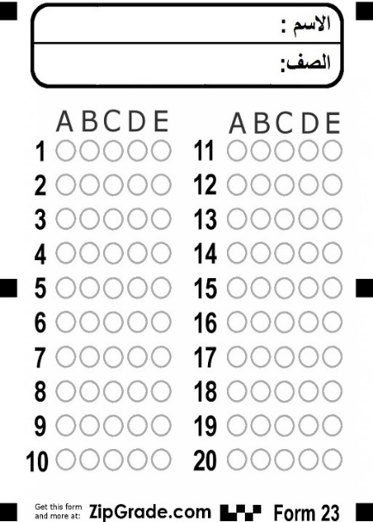

M.G 1.2 UNIT 1 & 2 B

Name……………………………………………………………. class..1\................

COMPERHENSION

One kind of boat is called a sailboat. A sailboat uses the wind to move. Wind makes a sailboat move in the water. The wind pushes the sailboat. Wind fills the sails. The sailboat moves when the wind blows. One kind of boat is called a motorboat. A motorboat uses a motor to move. The motor gives power to the boat. The motorboat moves when the motor is running. The motorboat makes a loud noise. One kind of boat is called a rowboat. A rowboat needs people to move it. People make a rowboat move in the water. People use oars to move a rowboat. Oars are long and flat. Oars go into the water. A rowboat moves when people use the oars. As you can see, there are many kinds of boats.

1) Which boat uses the wind to move?

A. a sailboat B. a rowboat C. a motorboat

) What is used to move a rowboat?2

A. wind B. a motor C. oars

) Which boat makes a loud noise? 3

A. a sailboat B. a motorboat C. a rowboat

GRAMMAR

Choose the right answer:

|  |  |  |
| --- | --- | --- |
| B |  | A |
| a- took back |  | 4-.. I don’t want to eat a lot of sugar,………… |
| Neither do I b- |  | 5-I finished reading the book and ………it to library. |
| c-had better |  | 6-.I live………Jeddah. |
| d-well |  | 7- My son Alexander drives…………but he sometimes drives too fast - |
| e-in |  | 8- she…….see a doctor. |

VOCABULARY

Match the word with meaning:

|  |  |  |
| --- | --- | --- |
| B |  | A |
| a-there's a different to think about something |  | 9- feeling down |
| an expression used to make statement b- |  | 10- I guess |
| c-feeling depressed |  | 11- lucky day |
| d-expression to show that you’re not totally sure about a statement |  | 12- to be honest |
| e-a day of good fortune |  | 13-look at it this way |

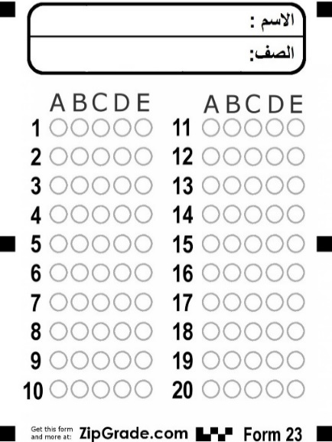

WRITING

**Write a paragraph about an accident accident**

……………………………………………………………………………………………………………………………………………………………………………………………………………………………………………………………………………………………………………………………………………………………………………………………………………………………………………………………………………………………………………………………………………………………………………………………………………………….………………..…………………………………………………………………………………………………………………………………………………………………………………………………………………………………………………………………………………………………………………………………………………………………………………………………………………………………………………………………………………………………………………………………………………………………………………………………………………………………….………………..…………………………………………………………………………………………………………………………………………………………………………………………………………………………………………………………………………………………………………………………………………………………………………………………………………………………………………………………………………………………………………………………………………………………………………………………………………………………………………………………………………………………………………………………………….…………….………………………………………………………………………………………………………………………………………………………………………………………………………………………………………………………………………………………………………………………………………………………………………………………………………………………………………………………………………………………………………………………………………………………………………………………………………………………………………………………………………………………………………………………………………………………………………………………………………………………………………………………………………………………………………………………………………………………………………………………………………………………………………………………………………………………………………………………………………………………………………………………………………………………………………………………………………………………………………………………………………………………………………………………………………………………………………………………………………………………………………………………………………………………………………………………………………………………………………………………………………………………………………………………………………………………………………………………………………………………………………………………………………………………………………………………………………………………………………………………………………………………………………………………………………………………………………………………………………………………………………………………………………………………..…………………………………………………………...

**Listening bc** .Finding the library

Complete the sentences with the words from the box

. fifty - off - office - card - quietly- food - six - two - lecture

1. The big building is the ……………… theatre.

2. The library is next to the registration ………………… .

3. You need a library …………… if you want to borrow books.

4. You can take out ………………… books.

5. You can keep library books for …………… weeks.

6. For every late day, you have to pay ……………… pence

. 7. Mobile phones must be switched………… and you cannot have ……..……… or drink

. 8. Please speak …………… in the library.