# Unit (1) Working 9 t0 5 Revision MG 2.2

***(subjunctive ) we use it to stress the importance or urgency of an action (use the base verb ( V inf )***

subjunctive

verbs

expressions

ask /demand / insist / recommend

request / require / suggest /urge

It is essential / It is imperative

It is important / It is necessary

Expression + that + s + **V** base form ..

S + V + that + s + **V** base form ..

it is essential that he **eat** healthy food

The doctor insisted that he **eat** healthy food

it is essential that he not **eat** fast food

The doctor insisted that he not **eat** fast food

***(I'd like you to / I want you to + V inf ) express a desire that someone do something***

**I’d like you to read**  **this story . (I'd ) I would**

**I'd like you to not read this novel**

**I want you to finish the report today .**

# Haapy Cute Kids Boy and Girl Study Stock Illustration - Illustration of homework, friends: 164179922



|  |  |  |  |  |  |  |  |
| --- | --- | --- | --- | --- | --- | --- | --- |
| **1** | **I would like you to ……………….my friend Maha next week .** | | | | | | |
| **A** | **meet** | **B** | **meets** | **C** | **met** | **D** | **meeting** |
| **2** | **I want you ……….. read this book .** | | | | | | |
| **A** | **for** |  | **to** |  | **at** |  | **that** |
| **3** | **It is imperative ………….the doctor wash his hands before entering the operating room** | | | | | | |
| **A** | **for** |  | **to** |  | **at** |  | **that** |
| **4** | **It is essential that you ……………. quit your job before you find a new one** | | | | | | |
| **A** | **not** |  | **doesn’t** |  | **didn’t** |  | **don’t** |
| **5** | **I want you to ……………… the report tomorrow** | | | | | | |
| **A** | **finishes** |  | **finish** |  | **finishing** |  | **finished** |
| **6** | **The teacher urged that we ………………hard for the exam** | | | | | | |
| **A** | **study** |  | **studies** |  | **studied** |  | **studying** |
| **7** | **I would like you to not …………….too fast .** | | | | | | |
| **A** | **drives** |  | **drive** |  | **driving** |  | **drove** |
| **8** | **It is important that we not …………….late for the meeting** | | | | | | |
| **A** | **is** |  | **were** |  | **be** |  | **are** |
| **9** | **I asked her to …………….. here on time** | | | | | | |
| **A** | **be** |  | **is** |  | **was** |  | **were** |
| **10** | **We recommend ………………put your educational background on it .** | | | | | | |
| **A** | **you that** |  | **that you** |  | **are you** |  | **you that not** |
| **11** | **I want ………………call me if you have any problem** | | | | | | |
| **A** | **to you** |  | **it you** |  | **you to** |  | **that you** |
| **12** | **I …………….like you to help with this project .** | | | | | | |
| **A** | **will** |  | **would** |  | **could** |  | **should** |
| **13** | **The boss demanded that he …………. late again** | | | | | | |
| **A** | **is not** |  | **be not** |  | **not be** |  | **not is** |

# Unit (1) Working 9 t0 5 Revision MG 2.2

***(Tag questions ) we use it to check information if it's correct or not and start a conversation***

**If the statement is positive , the question tag is** **negative**

**If the statement is negative , the question tag is positive**

**It was good , ……………..…………?**

**No, it wasn't**

**was it**

**Yes, it was**

**It wasn’t good , ………..…. ?**

**wasn’t it**

**No, she didn't**

**She didn’t study hard , did she ?**

**Yes, I am**

**You are from Riyadh , aren't you ?**

|  |
| --- |
| **Auxiliary verbs ( helping verbs )** |
| **am / is /are have /has can /could must /should will /would**  **was /were had** |

|  |  |  |  |  |  |
| --- | --- | --- | --- | --- | --- |
| **Present simple** | | | | **Past simple** | |
| **do** | **I /you / they /we** | **does** | **She / he /it** | **did** | **I / you / they /we/ she/ he/ it** |

|  |  |  |  |  |  |  |  |
| --- | --- | --- | --- | --- | --- | --- | --- |
| **1** | **The book wasn’t very good ,…………… ?** | | | | | | |
| **A** | **was it** | **B** | **was the book** | **C** | **were it** | **D** | **wasn’t it** |
| **2** | **It's too hot today ,…………….?** | | | | | | |
| **A** | **is it** |  | **isn’t it** |  | **wasn’t it** |  | **isn’t she** |
| **3** | **You are the new teacher ,……………….?** | | | | | | |
| **A** | **were you** |  | **are you not** |  | **are you** |  | **aren’t you** |
| **4** | **You didn’t break her vase ,……………?** | | | | | | |
| **A** | **did you** |  | **does you** |  | **didn’t you** |  | **wasn’t you** |
| **5** | **Alex is working in a bank now ,…………………..?** | | | | | | |
| **A** | **is he** |  | **isn’t he** |  | **is Alex** |  | **aren’t he** |
| **6** | **Mary made this cake ,……………?** | | | | | | |
| **A** | **did she** |  | **doesn’t she** |  | **didn’t she** |  | **don’t she** |
| **7** | **Eat your food ,……………….?** | | | | | | |
| **A** | **doesn’t you** |  | **will you** |  | **won't you** |  | **did you** |
| **8** | **Give me that pen ,……………… ?** | | | | | | |
| **A** | **doesn’t you** |  | **will you** |  | **won't you** |  | **did you** |
| **9** | **You miss your father ,………………..?** | | | | | | |
| **A** | **don’t you** |  | **do you** |  | **did you** |  | **didn’t you** |
| **10** | **She works out every day,……………………?** | | | | | | |
| **A** | **does she** |  | **doesn’t she** |  | **don’t she** |  | **didn’t she** |
| **11** | **you hadn’t cook dinner ,………………?** | | | | | | |
| **A** | **haven't you** |  | **hasn’t you** |  | **had you** |  | **hadn’t you** |
| **12** | **Let's play a game ,…………………?** | | | | | | |
| **A** | **will we** |  | **shall we** |  | **won't we** |  | **don’t we** |
| **13** | **I am late ,…………….?** | | | | | | |
| **A** | **I am not** |  | **aren’t I** |  | **am I** |  | **aren’t me** |
| **14** | **I am not late , ………..?** | | | | | | |
| **A** | **I am not** |  | **aren’t I** |  | **am I** |  | **Aren’t me** |

# Unit (1) Working 9 t0 5 Revision MG 2.2

***1-polite ways to ask for information with*** *Can, Could, Would****,*** *Would you mind*

When you ask people you don’t know

When you ask Family and friends

**Can you tell me where the mall is?**

**Where is the mall ?**

# الكرتون المدرسة الابتدائية المدرسة المدرسة, المراهق, أطفال الرسوم المتحركة, يذهب PNG وملف PSD للتحميل مجانا

***Can / Could / Would***

***Can you tell me where the bank is ?***

***Would you mind telling me where the bank is ?***

***Would you mind + Ving***

***2-polite ways to make requests with Can ,Could and Would + inf***

**Certainly.**

**Of course.**

**Sure.**

# Hello, friends!. Hello, friends! I'm fine thank you. And you? Good morning, Rafael. How are you? Good Morning, Bella. I'm fine thank you. And you? - ppt video online download

**Can you open the window, please?**

***Can / Could + you I***

***Would + you I***

# ❌” معنى: علامة X Emoji | EmojiAll

***3-express ( obligation / necessity / lack of necessity ) + Vinf***

|  |  |  |
| --- | --- | --- |
| obligation | necessity | Lack of necessity |
| must ( personal duties )have to (obligations to help others)mustn’t (not allowed to do it ) | I, you, we, they have toshe, he , it has to(past→ had to) (future→ will have to) need to  (past→ need**ed** to) (future→ will need to) | I, you. we, they don’t have toshe, he, it doesn’t have todidn’t have to / need to don’t / doesn't need to  needn’t to |

|  |  |  |  |  |  |  |  |
| --- | --- | --- | --- | --- | --- | --- | --- |
| **1** | **You ……………………pray 5 time a day** | | | | | | |
| **A** | **must** | **B** | **mustn’t** | **C** | **will need** | **D** | **had to** |
| **2** | **Would you mind ……………me with my resume ?** | | | | | | |
| **A** | **help** |  | **helps** |  | **helping** |  | **helped** |
| **3** | **Can I …………..to the manager ?** | | | | | | |
| **A** | **speak** |  | **speaks** |  | **speaking** |  | **spoke** |
| **4** | **I …………… write a report, so I didn’t hang out with my friends yesterday** | | | | | | |
| **A** | **will need to** |  | **had to** |  | **have to** |  | **mustn’t** |
| **5** | **He ………………….. go to work yesterday, it was Friday** | | | | | | |
| **A** | **didn’t need to** |  | **don’t need to** |  | **doesn't need to** |  | **aren’t need to** |
| **6** | **Tomorrow we ………………….get up early to catch the school bus .** | | | | | | |
| **A** | **had to** |  | **have to** |  | **will has to** |  | **will have to** |
| **7** | **It's not allowed to smoke in the waiting room, you ………………. smoke here** | | | | | | |
| **A** | **have to** |  | **mustn’t** |  | **need to** |  | **has to** |
| **8** | **Adel ……………………. be patient with the customers all the time .** | | | | | | |
| **A** | **has to** |  | **have to** |  | **had to** |  | **needed to** |
| **9** | **The people in line will ……………wait for their turn** | | | | | | |
| **A** | **has to** |  | **have to** |  | **had to** |  | **needed to** |
| **10** | **Mum ………….. cook tonight because we are going out for dinner** | | | | | | |
| **A** | **has to** |  | **have to** |  | **had to** |  | **needn’t to** |

Unit (1) Working 9 t0 5 Revision MG 2.2 Vocabulary

|  |  |  |  |  |  |  |  |
| --- | --- | --- | --- | --- | --- | --- | --- |
| **1** | **To be a ……………….is a job requires a person have kindness and consideration** | | | | | | |
| **A** | **race car driver** | **B** | **zoologist** | **C** | **nurse** | **D** | **lawyer** |
| **2** | **I spend a lot of time cutting and sewing, But I don’t work with fabric, I am ………………..** | | | | | | |
| **A** | **surgeon** |  | **zoologist** |  | **race car driver** |  | **air traffic controller** |
| **3** | **……………………is someone who helps people in need , poor or disabled** | | | | | | |
| **A** | **Social worker** |  | **Vet** |  | **zoologist** |  | **Screen writer** |
| **4** | **An arborist is a doctor for ………………….** | | | | | | |
| **A** | **children** |  | **animals** |  | **trees** |  | **old people** |
| **5** | **Circle the odd word** | | | | | | |
| **A** | **Doctor** |  | **No Parking** |  | **Cashier** |  | **telemarketer** |
| **6** | **Circle the odd word** | | | | | | |
| **A** | **No Entry** |  | **Speed Limit** |  | **No Parking** |  | **engineer** |
| **7** | **I'm in a ……………… the test is tomorrow and I can't understand it** | | | | | | |
| **A** | **jump ship** |  | **cover** |  | **bind** |  | **captive** |
| **8** | **A: I wanna tell you something but I need you to …………… B: you can trust me, it’s a secret** | | | | | | |
| **A** | **keep it to yourself** |  | **tell every one** |  | **spared it** |  | **tell your family** |
| **9** | **Ali : I won 5000 in the competition . Bader :……………..** | | | | | | |
| **A** | **certainly** |  | **no kidding** |  | **yes** |  | **sure** |
| **10** | **Ali: Did you Know that Imad ……………. Bader : He did! Where is he going to work now ?** | | | | | | |
| **A** | **jumped ship** |  | **in a bind** |  | **will not do it** |  | **No kidding** |
| 11 | **Ali: I am going to ……………now Bader: OK. See you later** | | | | | | |
| **A** | **no kidding** |  | **in a bind** |  | **take off** |  | **help you out** |

**Classify the items into the correct category :**

**( trend – fabric – sketches – style – natural – artificial – food – taste – trim – file nail – feet – captive )**

|  |  |  |
| --- | --- | --- |
| **doll fashion designer** | **flavorist** | **elephant pedicurist** |
|  |  |  |

|  |  |  |  |
| --- | --- | --- | --- |
| 1 | identical | (2) | free |
| 2 | captive | (1) | different |
| 3 | methodical | (4) | usual |
| 4 | unusual | (3) | disorganized |

**Match the words with their opposites**

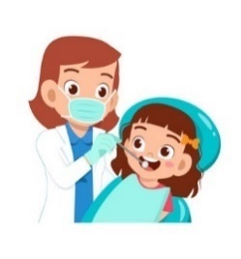

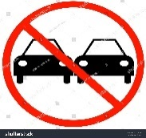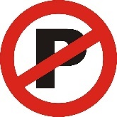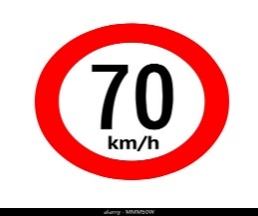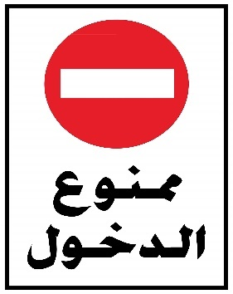

**Dentist**

**Speed limit**

**No Entry**

**No passing**

**No parking**

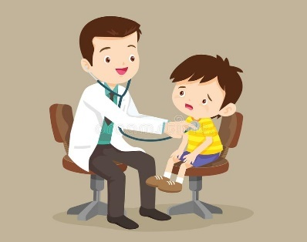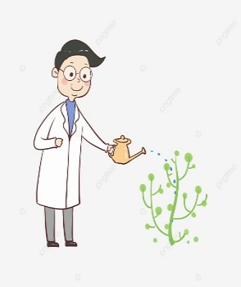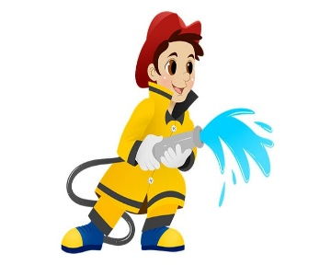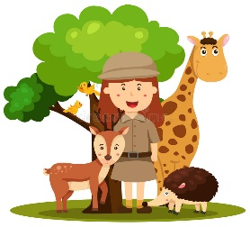

**firefighter**

**Pediatrician**

**arborist**

**zoologist**

**surgeon**