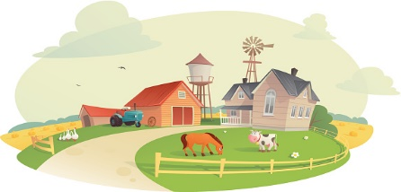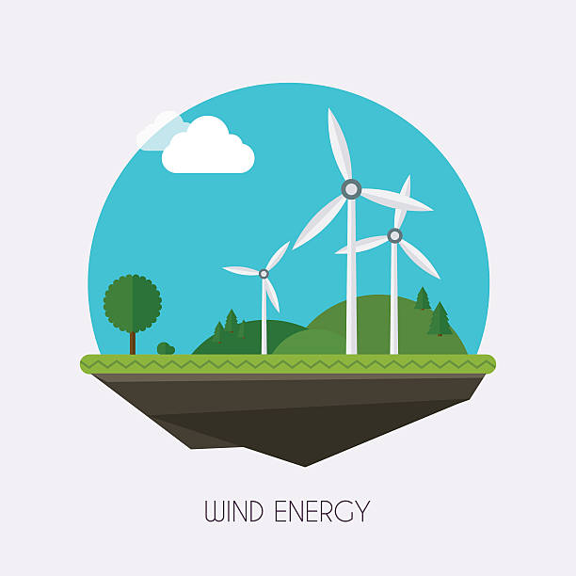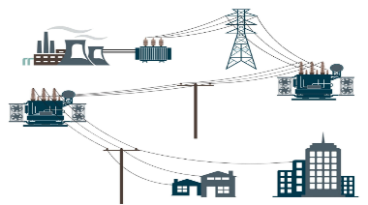

MG2.2 u2 reading

Why did some people decide to live off the grid?

…………………………………………………………..……………………………………………………………………………………………………………………………………..………………….………

How does a windmill produce electricity?

……………………………………………………………………………………………………………………………………………………..………..…………………………………………………………………………………..…………..

What is the grid?

……………………………………………………….………………………..……….……….……………………………………….……………….………………………………………………………………………………………………………..

Paragraph ( 3 )

Paragraph ( 2 )

Paragraph ( 1 )

Paragraph ( 4 )

Paragraph ( 5 )

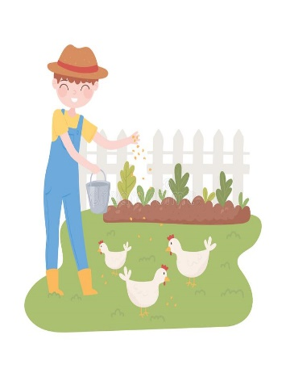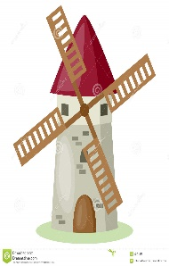

How do people who live off the grid create very little waste?

……………………………………………………………………………………………………………………………………………………………………………………………………………..…………..….

What are Jorge and Ella Alvarez's opinion about living off the grid?

……………………………………………………………………………………………………………………………………………………………………………………………………………..…………..….

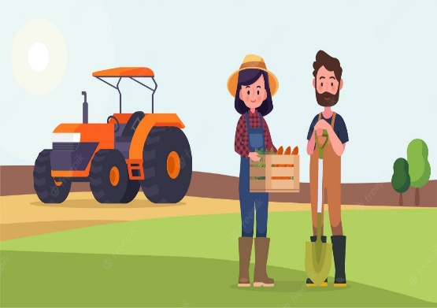

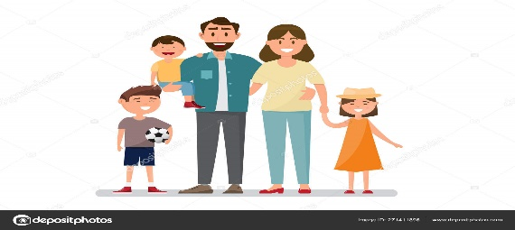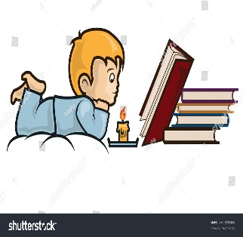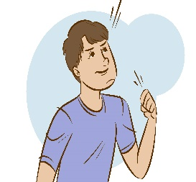

How does the

Johnstons family spend their

time when the power goes down?

…………………………………………………………………………………………………………………………………………………………………………………………………………….……..

What are the two things

Wendy wants for her children?

…………………………………………………………………………………………………………………………………………………………………………………………………………….……..

What is the " bold choice "

referred to in the text?

……………………………………………………………………………………………………………………………………………………………………………………………………………..…………..….

Paragraph ( 8 )

Paragraph ( 7 )

Paragraph ( 6 )