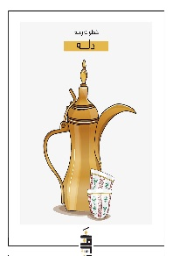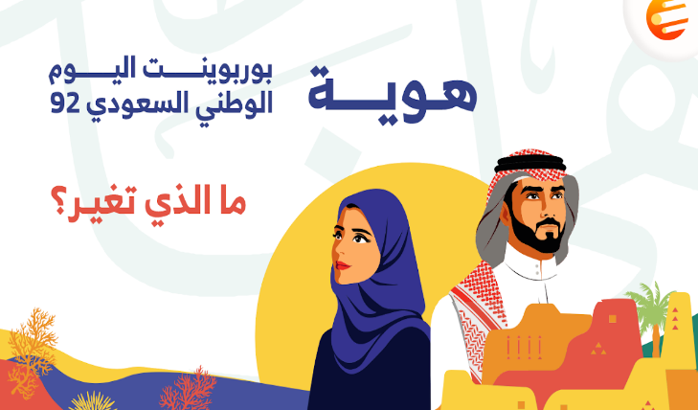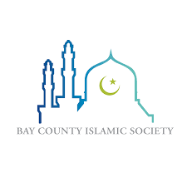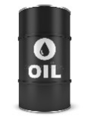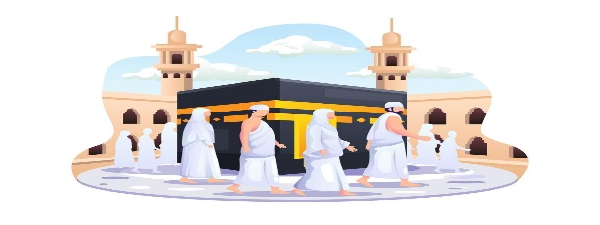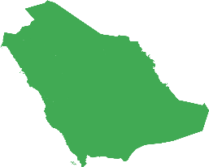

What are the blessings KSA has?

What makes it special?

…………………………………………………………..……………………………………………….……………………………………………………………………………………..……………………………......………………………………….………………………..…………………………………………….…….….…

What is the 2030 vision based on?

What support is necessary for

society to prepare for 2030?

……………………………………………………………………………………………………………….……………………………………..………..………………………………………………………………….………………..………………………………….……….…..

What is Saudi Arabia honored with? How many visitors did the expansion provide until 2020?

……………………………………………………….………………………..……….……….……………………………………….………..……….…………………………………………………………………….………

**MG2.2 U3 Reading**

**3**

**2**

**1**

**4**

**5**

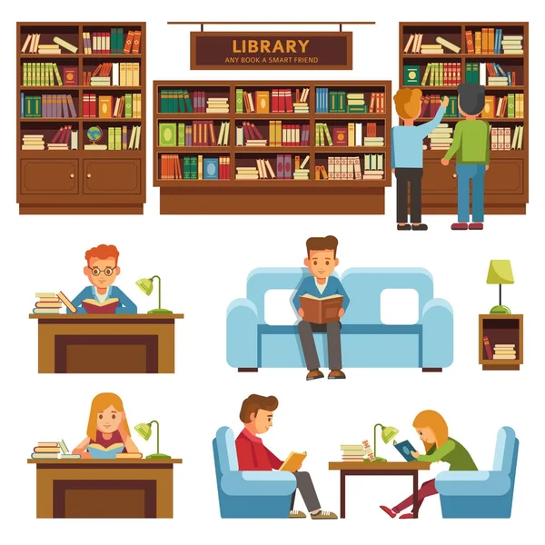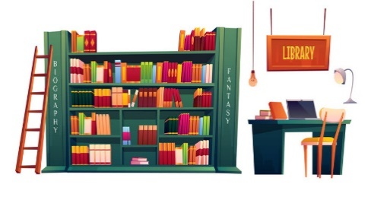

How will the educational system differ compared to the past?

……………………………………………………………………………………………………………………………………………………………………………………………………………..………………………………………………..…………………………………………..….

What will cultural and entertainment projects include?

…………………………………………..…………………………………………………………..…………………………………………………………..……………………………………………..…………………………………………………………………………..………..…



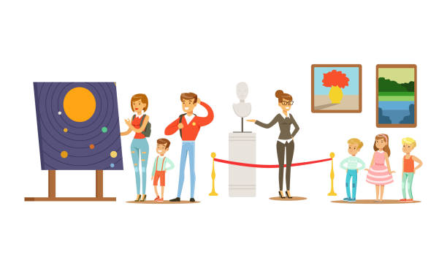

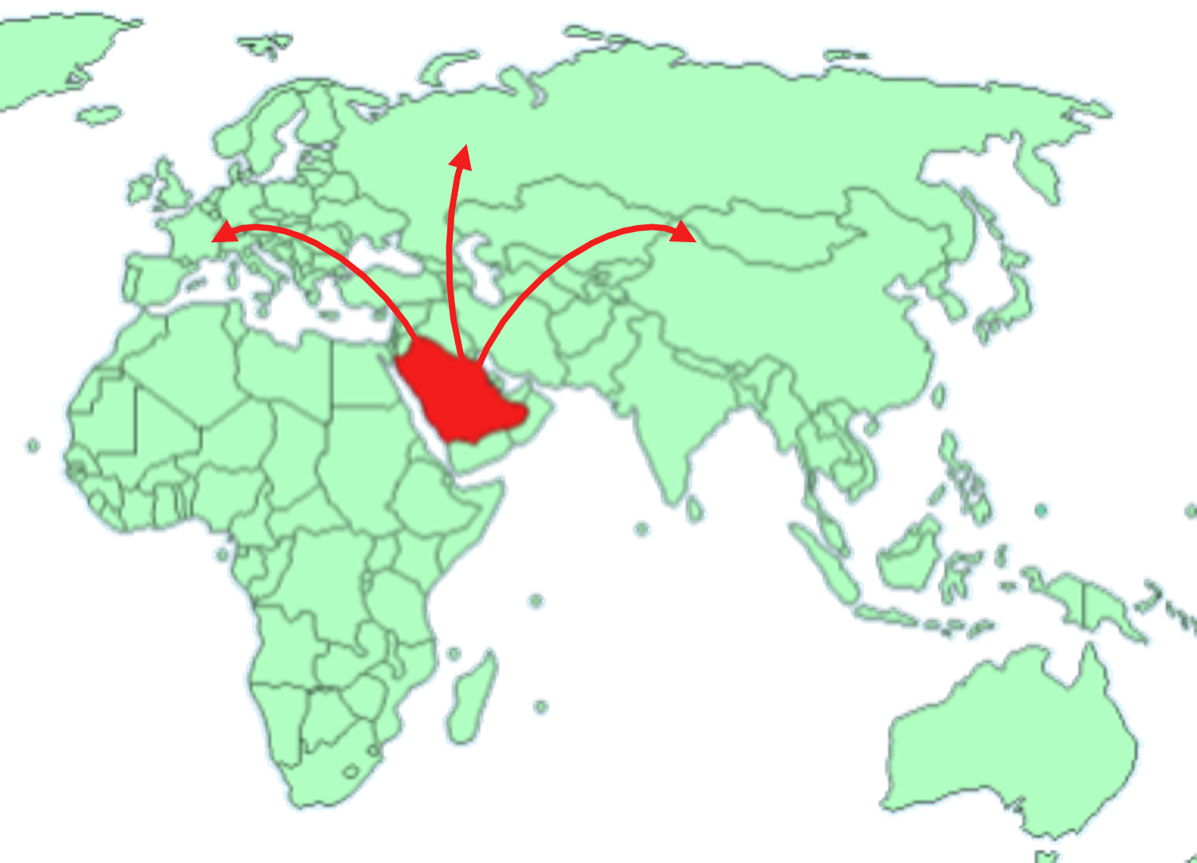

In what way will the

Kingdom's geographical position affect its role in international trade?

……………………………………………………………………………………………………………….………………………………………..………………………………………………………..………….…….……..

Will KSA be leading

business hub with limited opportunities?

……………………………………..…………………………………………………………..……………………………………………………………..……………………………………………..…...…………..….

How will the

renewed business environment benefits the economy?

……………………………………………………………………………………………………………………………………………………………………………………………………………………………………..…

Tr. Amal Al Sulami

**7**

**6**

**8**