# MG 2.2 Unit (3) There's No Place Like Home Revision

**Adjective Order ( O S A C O M )**

# Cuckooclock Modern Flat Design Style Single Isolated Object Stock Illustration - Download Image Now - iStockHappening Are depressed count up حقيبة سفر كرتون downstairs finish Consistent283,439 Table Cartoon Image Images, Stock Photos & Vectors | Shutterstockبناء منزل مخطط وحدات شاليه شاليه ، شاليه, بناء, خطة png

# كرسي صغير Png ، المتجهات ، PSD ، قصاصة فنية , تحميل مجاني | PngtreeCartoon two cup coffee expression design Vector Imageدراجة هوائية, حركة المرور, دراجة, عوارض PNG والمتجهات للتحميل مجانا

# 

|  |  |  |  |  |  |  |  |
| --- | --- | --- | --- | --- | --- | --- | --- |
| **determiner** | **Opinion** | **Size / Shape** | **Age** | **Color** | **Origin / Nationality** | **Material** | **noun** |
| an  a  this  that  these  those  it's | expensive  difficult  beautiful  great  terrible  lovely  comfortable | large  round  big  tiny/small  rectangle  triangular | young  ancient  new  old | red  turquoise  yellow  blue  grey  reddish | Saudi Arabia  British  Chinese  French  Italian  Greek | glass  wooden  clay  silk  velvet | **suitcase**  **house**  **mug**  **bike**  **table**  **clock**  **chair** |

**It's an expensive, new, blue suitcase**

**Look at these lovely, small mugs**

**( too / enough) ( not ) too + adj, adv /( not ) adj, adv + enough+ noun**

# لعبة الرجل العجوز الصغيرة

**( express sufficient )**

**(express more or less than necessary )**

**adj**

# Vector Illustration of Kid Playing with Building Blocks Stock Vector - Illustration of indoor, blocks: 116196977819 Basketball Hoop Clip Art Stock Vectors, Images & Vector Art | Shutterstock

**I'm too old** to play **basketball**

**I'm too young** to play **basketball**

**adj**

# 

**adv**

**I'm not old enough to play it**

**I move too slowly**

# Men are playing basketball. Flat design concept with guys who go in for sports playing ball. Vector illustrations of athletes on a white background Stock Vector Image & Art - Alamy

**adj**

**I'm not young enough to play**

**I'm old enough** to play **basketball**

**I move quickly enough** to win **the match**

**adv**

**not + adj + enough**

**not + too + adj**

**I'm not too old** to play

**too/enough are followed by an** infinitive phrase.

**I have enough skills** to join **the team**

**enough + noun**

**Tr. Amal Al Sulami**

|  |  |  |  |  |  |  |  |
| --- | --- | --- | --- | --- | --- | --- | --- |
| **1** | **Atheer had a ……………………….in her hair yesterday** | | | | | | |
| **A** | **nice yellow bow** | **B** | **yellow nice bow** | **C** | **bow nice yellow** | **D** | **bow yellow nice** |
| **2** | **She lost a …………………………** | | | | | | |
| **A** | **white small cat** | **B** | **cat small white** | **C** | **small white cat** | **D** | **small cat white** |
| **3** | **Look at these ……………… balloons** | | | | | | |
| **A** | **big red lovely** | **B** | **lovely big red** | **C** | **big lovely red** | **D** | **red lovely big** |
| **4** | **My uncle wore a ……………….to the wedding** | | | | | | |
| **A** | **tie silk blue** | **B** | **tie blue silk** | **C** | **silk blue tie** | **D** | **blue silk tie** |
| **5** | **The clown was wearing a ……………………** | | | | | | |
| **A** | **big green hat** | **B** | **hat green big** | **C** | **big hat green** | **D** | **hat big green** |
| **6** | **This bag is ……………..heavy to carry** | | | | | | |
| **A** | **to** | **B** | **enough** | **C** | **too** | **D** | **many** |
| **7** | **The water is warm ……………………we can go swimming** | | | | | | |
| **A** | **to** | **B** | **enough** | **C** | **too** | **D** | **many** |
| **8** | **The coffee was ………….to drink so I left it for a minute to cool** | | | | | | |
| **A** | **hot enough** | **B** | **too hot** | **C** | **hot too** | **D** | **enough hot** |
| **9** | **I didn’t buy the jacket because it was ……………………..** | | | | | | |
| **A** | **too big** | **B** | **big too** | **C** | **big enough** | **D** | **enough big** |
| **10** | **I didn’t get it cuz it was ………………. expensive** | | | | | | |
| **A** | **to** | **B** | **enough** | **C** | **too** | **D** | **many** |

# MG 2.2 Unit (3) There's No Place Like Home Revision

**Words Connected with Asking for, Understanding and Giving Directions**

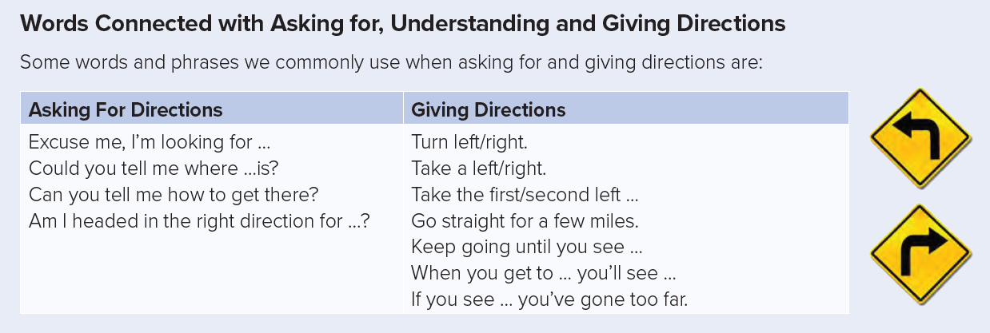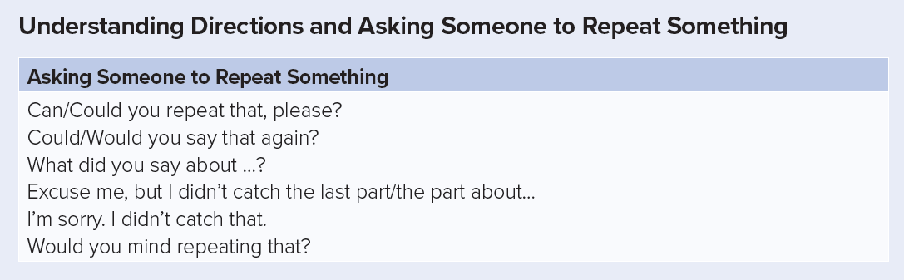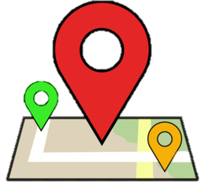

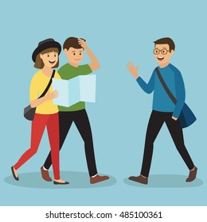

**Sure, just turn right then go straight take the first turn. You'll find it**

**Excuse me. We're looking for the museum. Could you tell us where it is?**

**Sorry but can you repeat that, please?**

**Express Request, Offers, Promises, Warning and Spontaneous Decisions**

|  |  |  |
| --- | --- | --- |
| Requests | Offers / Promises | Warning / Spontaneous decision |
| Can we sit here?  Will you close the window, please?  **The future with Dependent Time Clauses: When, Before, After, While, Until** | You look tired. I'll help you  I Will do my best next time. | I will tell your mom about the vase  ring ring ! I will answer it . |

**time clause (present simple = S +Vs /V inf)**

**main clause ( will +V inf )**

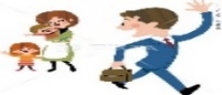

**I will go home when I finish work**

**When I finish work , I will go home**

|  |  |  |  |
| --- | --- | --- | --- |
|  | **Dad will call mom at home** | **before** | **Cartoon jet. stock vector. Illustration of flying, plane - 82231947we set off on our return journey** |
| **After** | **It stops raining** | **,** | **I will go to the store** |
|  | **I will help him with his H.W** | **while** | **Housewife to wash dishes - Stock Illustration [46972122] - PIXTAyou wash the dishes** |
|  | **I won't let you watch TV** | **until** | **Child Anxious To Make Up Homework PNG Transparent Image And Clipart Image  For Free Download - Lovepik | 401778977you finish your H.W** |
| **As soon as** | **I find anything** | **,** | Cara Mengonfirmasikan Informasi Melalui Telepon dalam Bahas Jepang Bisnis |  Belajar Bahasa Jepang Online | wkwkjapan**I will call you** |

**Tr. Amal Al Sulami**

|  |  |  |  |  |  |  |  |
| --- | --- | --- | --- | --- | --- | --- | --- |
| **1** | Choose the correct direction | | | | | | |
| **A** | Turn left | B | Go straight | C | Cross | D | Turn right |
| **2** | Would you mind …………………. that | | | | | | |
| **A** | repeat | B | repeats | C | repeating | D | repeated |
| **3** | A: when you get to the corner you will see the store B: ( ask to repeat the directions) | | | | | | |
| **A** | I didn’t catch that | B | Take the first turn | C | Take a left | D | I'm looking for … |
| **4** | **A:** Can you tell me where the bank is? **B:** Keep ……. until you see the yellow building. | | | | | | |
| **A** | go | B | goes | C | going | D | went |
| **5** | I ……………… finish the project on time this is a promise | | | | | | |
| **A** | Can't | B | will | C | would | D | may |
| **6** | Can I ………………two coffee and a cake please ? | | | | | | |
| **A** | has | B | have | C | had | D | having |
| **7** | The house won't be entirely mine until I ………….. off the mortgage. | | | | | | |
| **A** | pay | B | pays | C | paying | D | paid |
| **8** | When you come to the main road , you will ………….and look both ways | | | | | | |
| **A** | stop | B | stops | C | stopped | D | stopping |
| **9** | I'l I will help you with your H.W after I …………my own | | | | | | |
| **A** | do | B | does | C | did | D | done |
| **10** | When it …………..dark ,we'll stop . We can't work in the dark | | | | | | |
| **A** | get | B | gets | C | got | D | getting |

# MG 2.2 Unit (3)There's No Place Like Home Revision Vocabulary.

|  |  |  |  |  |  |  |  |
| --- | --- | --- | --- | --- | --- | --- | --- |
| **1** | **This old jacket has become too …………………….. I need to buy a new one** | | | | | | |
| **A** | **wealth** | **B** | **soul** | **C** | **worn** | **D** | **shelter** |
| **2** | **Sports fans show their ………………by wearing the colors of their favorite team** | | | | | | |
| **A** | **loyalty** | **B** | **furnish** | **C** | **atmosphere** | **D** | **comfort** |
| **3** | **I love to read in the library .it always has a quiet …………………….** | | | | | | |
| **A** | **loyalty** | **B** | **furnish** | **C** | **atmosphere** | **D** | **worn** |
| **4** | **A big house will …………. many people when you buy it you have to …………it** | | | | | | |
| **A** | **Furnish / loyalty** | **B** | **lodge / furnish** | **C** | **cost / lodge** | **D** | **lodge / soulless** |
| **5** | **Some people live in a house built from bricks and ………..and some use a tent as a …………..** | | | | | | |
| **A** | **Shelter / adobe** | **B** | **shelter / mortar** | **C** | **mortar / shelter** | **D** | **adobe / mortar** |
| **6** | **Circle the odd word** | | | | | | |
| **A** | **stay** | **B** | **worn** | **C** | **hold on** | **D** | **wait** |
| **7** | **An apartment like this will cost you an arm and a ……………………….** | | | | | | |
| **A** | **leg** | **B** | **head** | **C** | **neck** | **D** | **hand** |
| **8** | **Europe, Africa and Asia are …………………** | | | | | | |
| **A** | **cities** | **B** | **towns** | **C** | **continents** | **D** | **countries** |
| **9** | **A: It's nice outside. let's grab some coffee B: ……………I'll just get my coat** | | | | | | |
| **A** | **out of touch** | **B** | **hold on** | **C** | **grand** | **D** | **megabucks** |
| **10** | **A: How much did the watch cost you? B: A grand. It's one ………………….** | | | | | | |
| **A** | **hundred** | **B** | **thousand** | **C** | **million** | **D** | **billion** |
| **11** | **A: How can you operate this B: you must be ……………..just turn this button on** | | | | | | |
| **A** | **grand** | **B** | **hold on** | **C** | **megabucks** | **D** | **out of touch** |
| 12 | **A: So how was the party? B: it was ………………. I loved everything.** | | | | | | |
| **A** | **terrible** | **B** | **awful** | **C** | **Cool!** | **D** | **horrible** |
| **13** | **I am not rich enough to buy that house on the corner. It costs ………………..** | | | | | | |
| **A** | **two grand** | **B** | **hundred** | **C** | **an arm and leg** | **D** | **megabucks** |

**Classify the items into the correct category:**

**(living room, kitchen, bath room, furniture - pool , garage, garden , parking spot )**

|  |  |
| --- | --- |
| **interior** | **exterior** |
|  |  |

**(library, gallery, museum, zoo, exhibition – company, business, trade, sales, profits)**

|  |  |
| --- | --- |
| **Culture and Entertainment** | **The Economy** |
|  |  |

**Match the words with their meaning**

|  |  |  |  |
| --- | --- | --- | --- |
| 1 | hub | (2) | to care for the development and growth |
| 2 | nurture | (1) | the center of a region |
| 3 | cultivate | (4) | a valuable thing, person or quality |
| 4 | asset | (3) | to develop by study or training |

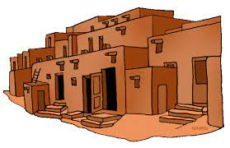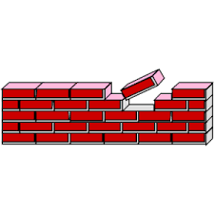



**adobe house**

**megabucks**

**brick**

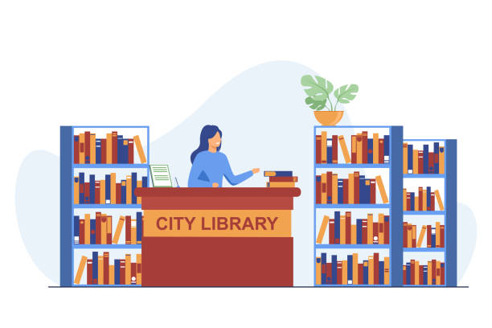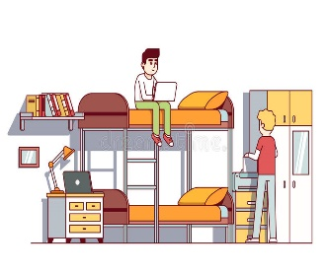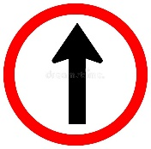

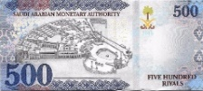

**grand**

**library**

**dormitory**

**economy**

**Go straight**

**Tr. Amal Al Sulami**