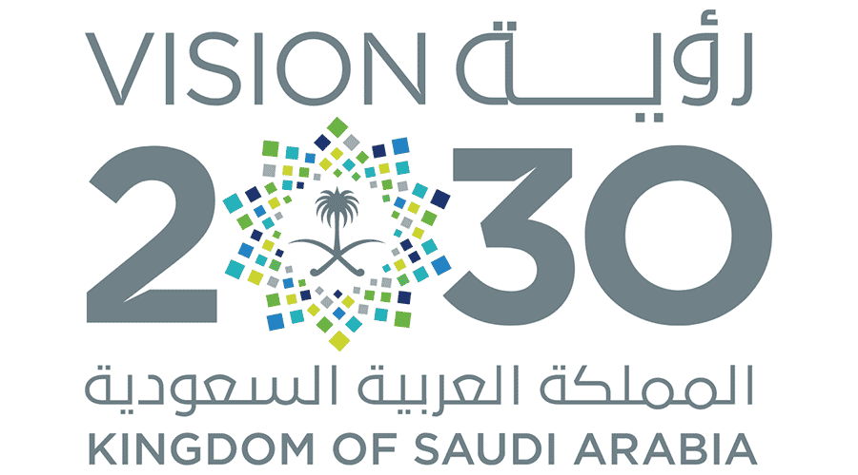

**Kingdom of Saudi Arabia**

**Ministry of Education**

**………… Education Directorate............**

**…………..……………….. Intermediate School**

|  |
| --- |
|  |
| **20** |

**Total**

**Midterm Test**

|  |
| --- |
| Second Intermediate Grade Model answer |

**نموذج إجابة**

__________________________________________________________________________________________

/ 5

**Comprehension**

**Read the following then answer the questions:**

My uncle has a small farm. He has a lot of chickens there. He sells eggs and chickens. Every summer, during the holiday I usually go to his farm to help him. I feed the chickens and collect the eggs. My uncle sometimes gives me chocolate

and money.

**A- Put (√ ) for true or ( ᵡ ) for false :**

|  |  |
| --- | --- |
| **( x )** | **1.**  My uncle has a big farm. |
| **( x )** | **1.**  My uncle sells cows and milk. |
| **( 🗸 )** | **2.**  I help my uncle in his farm. |

**B- Choose the right answer:**

|  |  |  |  |  |
| --- | --- | --- | --- | --- |
| **cows** | **chickens** | **dogs** | **cats** | 1. I feed the_________ in my uncle's farm. |
| **holiday** | **eggs** | **milk** | **chocolate** | **2-** My uncle sometimes gives me _____ and money. |

_____________________________________________________________________________________________________

/ 5

**Grammar**

**A-Choose the right answer:**

|  |
| --- |
| **1.** I ______ home yesterday.  **A . stayed B. stay C. stays D. staying** |
| **2.** What ___ you do last weekend?  **A . do B. does C. did D. doing** |
| **3.** There ____three accidents last week**.**  **A . was B. is C. are D. were B-Do as shown between brackets:**  **1.** I didn’t hear **__________**. I was **asleep. ( Choose ) [nothing / anything] 2- A.** I have some good news**.**  **B. _____** do I **. ( Choose ) [ Neither / So ]** |

/ 3

**Vocabulary**

**A- Choose the best answer to fill in the blank:**

|  |
| --- |
| **1.** The word calligraphy means**__________________.** |
| **A. different writing B. beautiful writing C. good writing D. bad writing** |
| **2**. I heard a _____ for help. “Over here! I’m stuck in the fence. |
| **A. smile B. laugh C. love D. cry** |
| **3-** Ahmed has a toothache. He should go to the _______ . |
| **A. nurse B. teacher C. dentist D. doctor** |

**B- Put the right word under its picture:**

|  |  |  |  |
| --- | --- | --- | --- |
| Headache PNG Images With Transparent Background | Free Download On Lovepik | Yawning Emoji Bored Sleepy Emoticon Yellow Stock Vector (Royalty Free)  1995226574 | Shutterstock | The Holy Quran, Qur an or Koran (the Recitation) is the Central Religious  Text of Islam, the Noble Quran Stock Photo - Image of arabic, calligraphy:  225670844 | Dinosaur Cartoon Black And White Vector Royalty Free SVG, Cliparts,  Vectors, and Stock Illustration. Image 48149621. |
| **Headache** | **Sleepy** | **The holy Qur’an** | **Dinosaurs** |

**The holy Qur’an - Sleepy – Dinosaurs – Headache**

/ 4

_______________________________________________________________________________

/ 3

**Orthography**

**Choose the correct letter:**

|  |  |  |  |
| --- | --- | --- | --- |
| C**. ( n )** | B**. ( g )** | A**. ( m )** | 1. There many people in the stadiu__. |
| C**. ( c )** | B**. ( s )** | A**. ( t )** | 2. Don’t be __hy. |
| B**. ( c )** C**. ( l )** | | A**. ( s )** | 3**.** Doctor, I feel si__k. |

Good luck T.