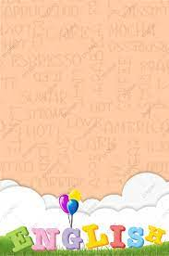

**توزيع منهج اللغة الانجليزية**

**للصف الثاني الثانوي**

**الفصل الدراسي الثاني 1445**

**Distribution of Syllabus**

**2nd Secondary**

**Second Semester 1445 H**

**2nd Secondary .. Second Term Distribution**

**4th Week**

**3rd Week**

**2nd Week**

**1st Week**

**19-5 // 3-12**

**26-5 // 10-12**

**26-5 // 10-12**

12-5 // 26-11

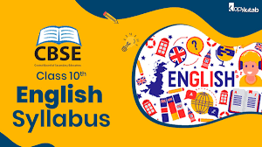****

**Unit 8**

**Sporting Life**

**Unit 8**

**Sporting Life**

**Unit 7**

**Home**

**Unit 7**

**Home**

**Unit 7**

**Home**

**Unit 6**

**Going Green.**

**Unit 6**

**Going Green.**

**Unit 5**

**Working 9 to 5**

**Unit 5**

**Working 9 to 5**

**Listening. / Conversation. / Reading.**

**Conversation / Writing /**

**Form, Meaning.**

**Listen & Discuss Grammar / Listening. / Conversation. / Reading.**

**Writing /**

**Form, Meaning.**

**Writing /**

**Form, Meaning.**

**Listening. / Conversation. / Reading.**

**Listening. / Conversation. / Reading.**

**Listen & Discuss Grammar**

**Listen & Discuss Grammar**

**Listen & Discuss Grammar**

**1-8 // 11-2**

**23-7 // 4-2**

**17-7 // 29-1**

**9-7 // 21-1**

**18-6 // 31-12**

**Unit 6**

**Going Green.**

**Unit 5**

**Working 9 to 5**

**Writing /**

**Form, Meaning.**

**8-8 // 18-2**

**2-7 // 14-1**

**11-6 // 24-12**

معلم المادة

**Final**

**Exams**

مدير المدرسة

**8th Week**

**12th Week**

**11th Week**

**10th Week**

**9th Week**

**7th Week**

**6th Week**

**5th Week**