Cave houses  1- comfortable = ( bad – big – relaxed )  Prize : no homework | House boats  1- Crowded = ( a few – a lot of – big ) people  Prize : no dictation
Cave houses  2- natural # ( usual – unusual – normal )  Prize : 5 SR of canteen | House boats  2- different # ( small– hot – same )  Prize : no homework
Cave houses  3- when did they made these houses?  Prize : no dictation | House boats  3- what kind of people like to live there?  Prize : hard luck =) next time
Cave houses  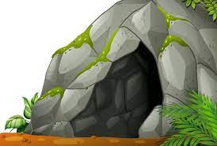  4- = ( canal – cave – boat )  Prize : hard luck =) next time | 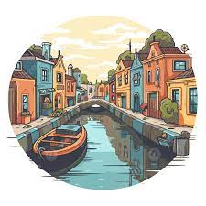  House boats  4- = ( canal – house – boat )  Prize : no writing in notebook
Cave houses  4-there were no electricity in cave houses ( T - F )  Prize : no writing in notebook | House boats  1- there are enough houses in Amsterdam ( T - F )  Prize : 5 SR of canteen

