



**We can 3**

Name: ……………………………………………………………….

Class: …………………………………………………………………

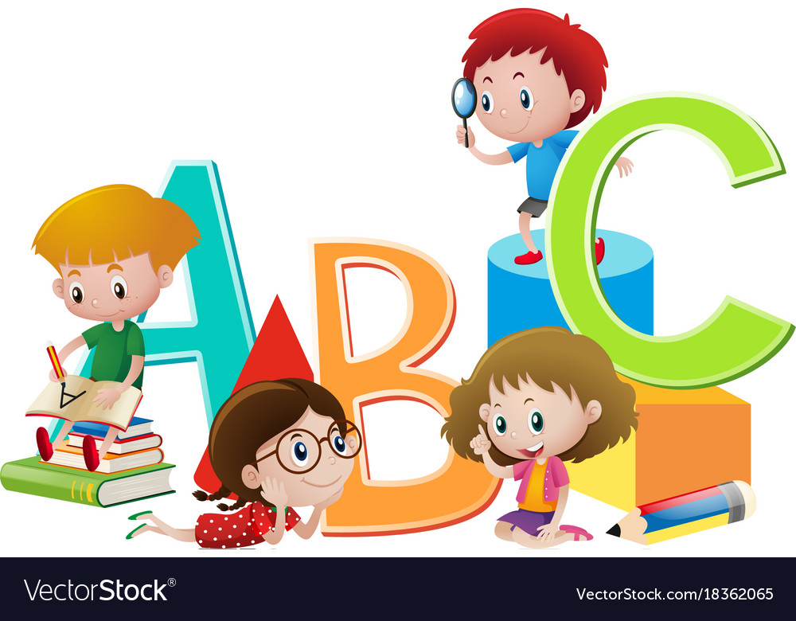

**Teacher’s notes**

|  |  |
| --- | --- |
| **Unit 5** |  |
| **Unit 6** |  |
| **Unit 7** |  |
| **Unit 8** |  |

What time is it?

***U5: Yesterday & Today Finding out time Date: / /1445H H***

|  |  |  |
| --- | --- | --- |
| It is | o’clock | one  two  three  four  five  six  seven  eight  nine  ten  eleven  twelve |
| 15 min |
| 30 min |
| 45 min |

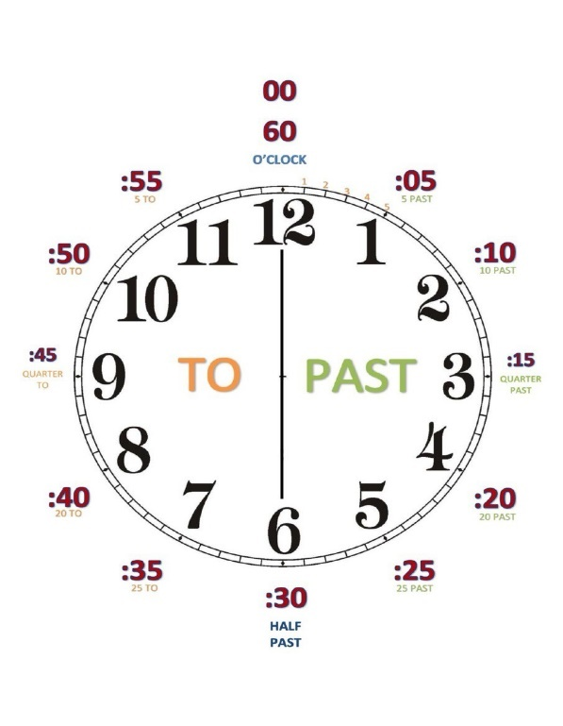

1. *What is the time?*

|  |  |  |  |
| --- | --- | --- | --- |
| 1 | 2 | 3 | 4 |
| a. five o’clock | a. six o’clock | a. eleven fifteen | a. eight o’clock |
| b. one ten | b. eight thirty | b. two o’clock | b. three thirty |
| c. six thirty | c. five forty | c. ten thirty | c. four forty |

1. *Read the time then draw hands on the clock*

|  |  |  |  |
| --- | --- | --- | --- |
| 1 | 2 | 3 | 4 |
| Three thirty | Seven fifteen | Ten forty five | eight o'clock . |

1. *copy :*

###### 

###### I usually get up at five o'clock.

###### 

###### 

***U5: Yesterday & Today Grammar in Action Date: / /1445H***

Daily Activity

|  |  |  |  |  |  |
| --- | --- | --- | --- | --- | --- |
|  |  |  |  |  |  |
| get up | eat lunch | come home | do my homework | take a bath | go to bed |
|  |  |  |  |  |  |

1. *Write the past tense forms:*
2. I **eat** lunch . ...........................................................................................

2- I **go** to bed. ...........................................................................................

1. 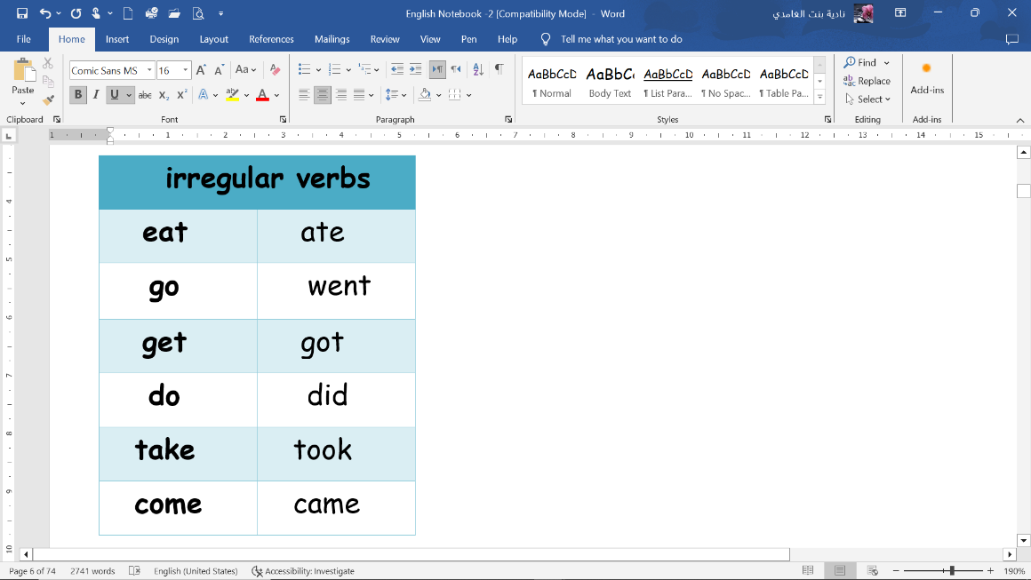*Choose the correct answer :*
2. I usually ***( get - got )*** up at five o'clock.
3. Yesterday I ***( get - got )*** up at five o'clock. 3- I usually ***(do – did)*** my homework at 4 o'clock .

4- Yesterday I ***(do – did)*** my homework at 4 o'clock . 5- I usually ***(took – take)*** bath at 9 o'clock .

6-Yesterday I ***(took – take)*** bath at 9 o'clock .

1. *Rearrange the words to make sentence in the past tens:*

1- ate – lunch – I .......................................................................................................

1. came – They – home ..............................................................................................
2. *copy :*

###### 

###### Yesterday, I got up at quarter past five.

###### 

###### 

***U5: Yesterday & Today Rhythms and Reading Date: / /1445H***

Daily Activity

|  |  |  |  |  |  |  |
| --- | --- | --- | --- | --- | --- | --- |
|  |  |  |  |  |  |  |
| jump out of bed | brush my teeth | finish school | ride the bus | meet friends | jump into bed | dream |
|  |  |  |  |  |  |  |

1. *Match the questions with the answers :*

|  |  |  |
| --- | --- | --- |
| 1- What time is it ? |  | I usually go to bed at 9:00. |
| 2- What time do you go to bed? |  | Yes , I do. |
| 3- Do you like cheese ? |  | It’s twenty past nine . |

1. *Match sentences with pictures:*

|  |  |  |  |
| --- | --- | --- | --- |
| 1 | 2 | 3 | *sock****sock***sock4 |
| ( )  It’s six forty five | ( )  It’s one ten | ( )  It’s eleven thirty. | ( )  It’s three o’clock |

1. *copy :*

###### 

###### Sleep early to be healthy.

###### 

###### 

***U5: Yesterday & Today Phonics Date: / /1445H***

1. *Fill in the missing letter :*

|  |  |  |  |  |  |
| --- | --- | --- | --- | --- | --- |
|  |  |  |  |  |  |
| dri _ _ | spri _ _ | i _ _ | ri_ _ | ba _ _ | clo _ _ |
|  |  |  |  |  |  |
| _ _ale | Tele_ _one | _ _ip | _ _ ocolate | _ _ eese | Dol_ _in |

*2) Unscramble the following to make meaningful paragraph:*

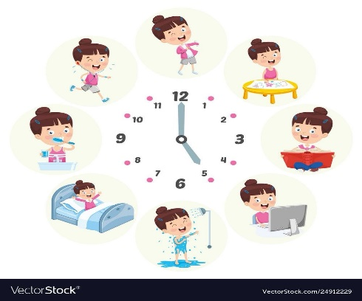

1. get up / at 5 o’clock / I / usually

2. I / to school / go / by bus

3. come home / usually / I/ at 12 o’clock

4. my homework / at 4 o’clock / do / I

5. usually / go to bed / I / at 8 o’clock

……………………………………………………………………………………………………………………………………………………………….

……………………………………………………………………………………………………………………………………………………………….

……………………………………………………………………………………………………………………………………………………………….

……………………………………………………………………………………………………………………………………………………………….

……………………………………………………………………………………………………………………………………………………………….

……………………………………………………………………………………………………………………………………………………………….

……………………………………………………………………………………………………………………………………………………………….

……………………………………………………………………………………………………………………………………………………………….

***U6: Jobs Finding out time Date: / /1445H***

|  |  |  |  |  |
| --- | --- | --- | --- | --- |
|  |  |  |  |  |
| doctor | nurse | cook | astronaut | housewife |
|  |  |  |  |  |
|  |  |  |  |  |
| engineer | reporter | architect | pilot | diver |
|  |  |  |  |  |
|  |  |  |  |  |
| firefighter | teacher | computer technician | businessman | lawyer |
|  |  |  |  |  |

1. *Answer the following question :*



1- What does she do ?

She is a .......................................

 2- What does he do ?

He is a .........................................

1. *Copy :*

###### 

###### My dad is an engineer.

###### 

###### 

***U6: Jobs Grammar in Action Date: / /1445H***

|  |  |  |  |
| --- | --- | --- | --- |
|  |  |  |  |
| restaurant | Fire station | airport | hospital |
|  |  |  |  |

*1) Choose the right answer*

1-The doctor works in the……

a- hospital b- school c- restaurant

2-A …………………………….. cooks in the restaurant.

a- nurse b- cook c- firefighter

3-A …………………………….. teaches children.

a- lawyer b- pilot c- teacher

1. *Match :*

|  |  |  |
| --- | --- | --- |
| Work in the space station |  | 1. Restaurant. |
| Help sick people |  | 2. firefighters |
| a place to eat. |  | 3. pilots |
| Put out fire |  | 4. astronaut |
| Fly planes |  | 5. doctor |

1. *Copy :*

###### 

###### Teachers teaches children.

###### 

###### 

***U6: Jobs Rhythms and Reading Date: / /1445H***

|  |  |  |  |  |
| --- | --- | --- | --- | --- |
|  |  |  |  |  |
| designer | baker | scientist | writer | presenter |
|  |  |  |  |  |

1. *Write about yourself . Answer the following question :*

1-What do you want to be when you grow up ?

2- Why ?

3- Where do you want to work?

……………………………………………………………………………………………………………………………………………………………….

……………………………………………………………………………………………………………………………………………………………….

……………………………………………………………………………………………………………………………………………………………….

……………………………………………………………………………………………………………………………………………………………….

1. *Copy :*

###### 

###### When I grow up, I want to be a doctor.

###### 

###### 

###### *Fill in the missing letter :*

***U6: Jobs Phonics Date: / /1445H***

|  |  |  |  |  |  |
| --- | --- | --- | --- | --- | --- |
| بدون عنوان-2.gif | بدون عنوان-1.gif | بدون عنوان-1.gif | بدون عنوان-2.gif | بدون عنوان-1.gif | بدون عنوان-1.gif |
| ri _ _ t | _ _ ife | _ _ock | _ _ob | _ _ee | li _ _t |

1. *Choose the correct pronunciation:*

|  |  |  |  |  |  |
| --- | --- | --- | --- | --- | --- |
|  |  |  |  |  |  |
| reads | Walks | teaches | washes | eats | runs |
| /z/  /s/  /iz/ | /z/  /s/  /iz/ | /z/  /s/  /iz/ | /z/  /s/  /iz/ | /z/  /s/  /iz/ | /z/  /s/  /iz/ |

*3) Unscramble the following to make meaningful paragraph:*



1. I / when / grow up/ want to be / I / a pilot

2. fly / planes / pilots

3. travel / around / the world / pilots

4. work / they / in / the airport

……………………………………………………………………………………………………………………………………………………………….

……………………………………………………………………………………………………………………………………………………………….

……………………………………………………………………………………………………………………………………………………………….

……………………………………………………………………………………………………………………………………………………………….

……………………………………………………………………………………………………………………………………………………………….

……………………………………………………………………………………………………………………………………………………………….

……………………………………………………………………………………………………………………………………………………………….

……………………………………………………………………………………………………………………………………………………………….

***U7: Fun on the Weekend Finding out time Date: / /1445H***

|  |  |  |  |  |  |
| --- | --- | --- | --- | --- | --- |
|  |  |  |  |  |  |
| clean | practice | watch | kick | study | cook |
|  |  |  |  |  |  |
|  |  |  |  |  |  |
| stay home | trampoline | DVD | boring | okay | scary |
|  |  |  |  |  |  |

1. *Answer the following question :*

1- What did you do over the weekend?

 ................................................................................................................................

2- What did he do in the weekend?

................................................................................................................................

1. *Copy :*

###### 

###### He practiced on the trampoline.

###### 

###### 

***U7: Fun on the Weekend Grammar in Action Date: / /1445H***

|  |  |
| --- | --- |
| Regular verbs | |
| cook | cooked |
| clean | cleaned |
| watch | watched |
| practice | practiced |
| stay | stayed |
| play | played |
| study | studied |
| kick | kicked |

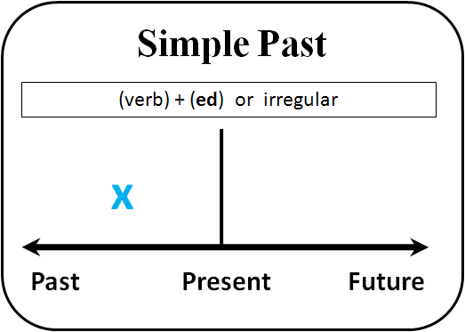

1. *Choose the correct answer:*

1- She ***( cooked – cleaned – kicked )*** the breakfast . 2- You ***( stayed – cooked - watched )*** a DVD.

3- We **(watched -stayed- *kicked )*** at home.

1. *Fill in the blanks using the simple past tense forms of the verbs given in the brackets:*

1-I ...............................................***(practice)*** my English.

2-They ......................................***.(clean)*** the house.

3- You......................................... ***(study)*** a little.

4-You ......................................... (***play*** ) outside.

5- He ..........................................***(kick )*** a ball.

1. *Copy :*

###### 

###### She cooked a big breakfast.

###### 

###### 

***U7: Fun on the Weekend Reading and writing Date: / /1445H***

|  |  |  |  |
| --- | --- | --- | --- |
| **How much………..?** | **How much………..?** | **Some** | **Any** |
| Uncountable nouns: we can’t count it. | Countable nouns: we can count it. | Affirmative sentence . | Negative sentence .  ( not ) |
| Pens, books, flowers,  tomatoes | Flour, oil, cheese | We have some flour. | We don’t have any oil. |

|  |  |  |  |  |
| --- | --- | --- | --- | --- |
| How many | pens  books  flowers  tomatoes | do | I  you  we  they | want?  need?  have? |
| How much | flour  oil  cheese | does | he  she  it |

1. *Choose the right verb :*

1- How ( much –many –old ) flour do you want?

2- How ( much –many –old ) tomatoes does she have?

3- How (much –many –old ) peppers do you need?

4- How (much –many –old ) mushrooms do we need?

5- How ( much –many –old ) oil do you want?

6- We have ( any –some ) eggs in the fridge.

7- I don't have ( any –some ) flour.

8- We don’t have ( any –some ) oil.

1. *Copy :*

###### 

###### I’d like fruit sala, please.

###### 

###### 

***U7: Fun on the Weekend Phonics Date: / /1445H***

###### *Fill in the missing letter :*

|  |  |  |  |  |  |
| --- | --- | --- | --- | --- | --- |
|  |  |  |  |  |  |
| sa _ _ | te_ _ | ha_ _ | pai_ _ | sta_ _ | pla _ _ |

###### *Write the correct word under the correct column:*

|  |  |  |  |  |  |
| --- | --- | --- | --- | --- | --- |
| Coloring book, Grapefruit stock vector. Illustration of grapefruit -  127898461 | Clipart Of Coat, Black Coat And Closet - Coat Clipart Black And White, HD  Png Download - kindpng |  | Suit Clipart Black And White, HD Png Download , Transparent Png Image -  PNGitem |  |  |
| grapefruit | coat | skateboard | Suit | Ski boots | mangoes |

|  |  |  |
| --- | --- | --- |
| **fruit store** | **sport store** | **clothing store** |
|  |  |  |
|  |  |  |

###### *Match :*

|  |  |  |
| --- | --- | --- |
| 1- You can buy suits at……. |  | a sport store. |
| 2- What would you like? |  | Yes, please. |
| 3- You can buy mangoes at…….. |  | a clothing store. |
| 4-What did you do over the weekend? |  | I’d like salad please. |
| 5-You can buy ski boots at…….. |  | a fruit store. |
|  |  | I cooked a big breakfast |

***U8: Life’s Up and Down Finding out time Date: / /1445H***

|  |  |  |  |
| --- | --- | --- | --- |
|  |  |  |  |
| won the game | got first place | lost game | caught a cold |
|  |  |  |  |
|  |  |  |  |
| had an operation | make a rocket | Stuck in an elevator | broke my leg |
|  |  |  |  |

*1) Choose the right answer*

1-What good thing happened to you last year?

a- I caught a cold. b- I lost game. c- I got the first place in school

2- What bad thing happened to you last year?

a- I broke my leg. b- I made a rocket. c- I won the race.

*2) Copy :*

###### 

###### I got first place in a race.

###### 

###### 

***U8: Life’s Up and Down Grammar in Action Date: / /1445H***

*1) Write the past form of the verbs*

|  |  |  |  |
| --- | --- | --- | --- |
| Verb | Past form | Verb | Past form |
| 1-lose |  | 6-make |  |
| 2-win |  | 7-see |  |
| 3-get |  | 8-catch |  |
| 4-is |  | 9-have/has |  |
| 5-are |  | 10-break |  |

*2) Match pictures with sentences*

|  |  |  |  |  |
| --- | --- | --- | --- | --- |
| 1 | 2 | 3 | 4 | 5 |
| ( )  I caught a big fish. | ( )  I broke my glasses. | ( )  I made a tree house. | ( )  I got 100 points. | ( )  We won a football game. |

*3) Copy :*

###### 

###### We were happy.

###### 

###### 

***U8: Life’s Up and Down Reading and Writing Date: / /1445H***

|  |  |  |  |
| --- | --- | --- | --- |
|  |  |  |  |
| meat | chicken | Butter | macaroni |
|  |  |  |  |
|  |  |  |  |
| interesting | boring | difficult | easy |
|  |  |  |  |

*1) Write the past form of the verbs*

|  |  |  |  |
| --- | --- | --- | --- |
| Verb | Past tens | Verb | Past tens |
| 1-go |  | 2- come |  |

*2) Copy :*

###### 

###### I think it’s funny.

###### 

###### 

***U8: Life’s Up and Down Phonics Date: / /1445H***

|  |  |
| --- | --- |
| **Subject pronouns** | **Object pronouns** |
| **I** | **me** |
| **She** | **her** |
| **He** | **him** |
| **we** | **us** |
| **They** | **them** |
| **You** | **you** |

###### *Fill in the missing letter :*

|  |  |  |  |  |  |
| --- | --- | --- | --- | --- | --- |
|  |  |  |  |  |  |
| _rog | _ _one | lau_ _ | _ riends | _ _oto | ele _ _ ant |

###### *2) Change the underlined words :*

|  |  |
| --- | --- |
| 1- He saw **Ali** . |  |
| 2- He saw **Sara**. |  |
| 3- She saw **the teacher**. |  |
| 4- She saw **the girls**. |  |

###### *3) Choose the correct words :*

1- Yesterday,( we – us – me ) went to an adventure park.

2- I saw my friends and played with ( him – he -them).

3- She calls ( I – me – we).

4- I met ( her- she – they) in the school.

**My verbs list**

|  |  |  |  |
| --- | --- | --- | --- |
| Verb | Past form | Verb | Past form |
|  |  |  |  |
|  |  |  |  |
|  |  |  |  |
|  |  |  |  |
|  |  |  |  |
|  |  |  |  |
|  |  |  |  |
|  |  |  |  |
|  |  |  |  |
|  |  |  |  |
|  |  |  |  |
|  |  |  |  |
|  |  |  |  |
|  |  |  |  |
|  |  |  |  |
|  |  |  |  |
|  |  |  |  |