**Revision Unit 7 Where do you live?**

**Name:……………………… Class: 1/..**

**☺ vocabulary**

1. Match the words with the correct pictures:

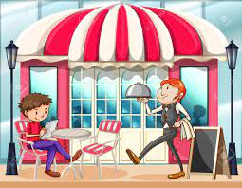( restaurant - pharmacy – bookstore – bank – bridge- park)

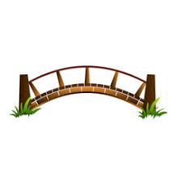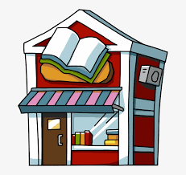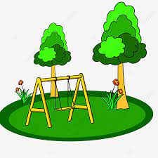

……………….. ……………….. ……………….. ……………….. ……………….. ………………..

1. Choose the correct answer:

( floor – park – believe me – near – bookstore – health club- restaurant)

1. I eat pizza at the ……………………………..
2. A …………………………….is a place to exercise.
3. A …………………………….is a place to buy books.
4. The opposite of (far ) is …………………………….
5. She lives on the first …………………………….
6. I play with my friends in the …………………………….
7. "Trust me" means …………………………….
8. Choose the ***odd*** word:
9. hotel –window -restaurant – bank
10. left- right- city - straight

**☺ Grammar**

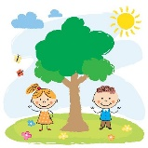A) Choose the correct answer:

1. I live ( on – in – of ) Jeddah.
2. My sisters lives ( on – in – at) the second floor.
3. The children are ( far – on – near) the tree.
4. 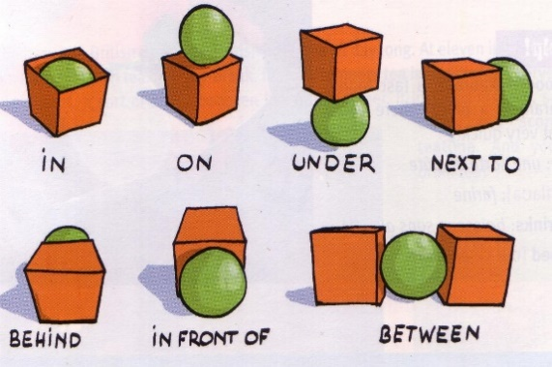The bus stop is ( on – between – far) the corner.
5. My friends aren't from Jeddah. (He –They – You) are from Abha.
6. The ball is ( between – under – next to) the box.
7. Ali is ( tall – taller – the tallest) than Omar.
8. You are ( good – better – the best) in the class.
9. Of all the taxi drivers, Jack is (the most careful- more careful- careful).
10. Elephants are ( big – bigger- the biggest) than monkeys.

**☺ Orthography**

1. Choose the correct letter:
2. apart…..ent ( m- n- l) 4- ho…..el (r- x- t)
3. pa….. k (r- b- q) 5- s….. bway (e- u- a)
4. bui…..ding (m-l- v) 6- ba…..k (m-n-d)

👍Good luck