Name: ……………………………………… Ms. Tahani ☺

Class: 3rd Intermediate

**Revision Sheet _ Unit ( 6 ) : Do You Know Where It Is?**

1. **Vocabulary:**
2. **Write the words under the pictures:**

**bullet train – bridge – commuters – fountain - suburb**

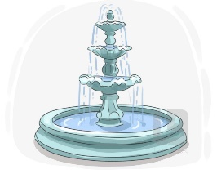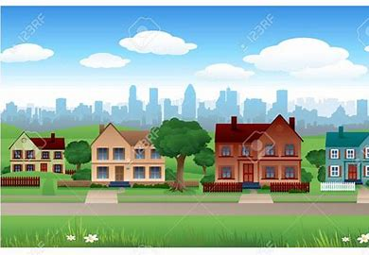



**________________ __________________ ___________________ __________________**

1. **Classify the words:**

**crime rate – taxis – kilometres**

|  |  |  |
| --- | --- | --- |
| **Vehicle** | **Measurement words** | **Features of town** |
|  |  |  |

1. **Circle the odd word:**
2. **Vehicle:** car – stadium – bus – taxi
3. **Features of town:** green area – cost of housing – clean air – mile
4. **Match:**
5. run down a- holds
6. consecutive b- an unbroken series
7. leading c- in needed of fixing / not looked after
8. combination d- popular

e- mixture

1. **Fill in the blank with the correct words in the box:**

**renovate – fare – survey – efficient – transportation**

1. [There is public ………………………. available throughout the city.](http://www.talkenglish.com/audio871/audiovocab/f2/transportation/transportation03.mp3)
2. The ……………… questions were not very clear.
3. The homeowners decided to ………………. their old kitchen.
4. Ali is very ……………….. at his job.
5. **Match the word with its opposite:**
6. narrow a- high
7. low b- cheap
8. polluted c- wide
9. cozy d- uncomfortable

e- clean

1. **Grammar:**
2. **Choose:**
3. Fadi is **(tall – taller – tallest)** .
4. Hatem is **(tall – taller – tallest)** than Samer.
5. Rama is the **(tall – taller – tallest)** student in the class.
6. The chair is **(comfortable – more comfortable – most comfortable)**.
7. The sofa is **(comfortable – more comfortable – most comfortable)** than the chair.
8. The bed is the **(comfortable – more comfortable – most comfortable)** furniture.
9. Leen’s marks are **(good – better – best)** than her friend.
10. Dammam has the **(bad – worse – worst)** weather in Saudi Arabia.
11. Your sister is as **(smart – smarter – smartest)** as you.
12. Your mobile **(is not as – is as not – not is as)** new as mine.
13. **(A – An – The)** sun rises in the east and sets in the west.
14. The bird is flying in **(the – a – an)** sky.
15. **Do as shown between brackets:**
16. Where is the supermarket?  **(Make indirect question)**

…………………………………………………..

1. When does the shop open? **(Make indirect question)**

…………………………………………………..

1. Wafa’s hair is **long** than Faten’s. **(Correct the mistake)**

…………………………………………………..

1. Dana is in the Jeddah on vacation.  **(Correct the mistake)**

…………………………………………………..