Name: …………………………………… Ms. Tahani ☺

Class: 2nd Intermediate

**Revision Sheet _ Unit ( 7 ) : What Happened?**

1. **Vocabulary:**
2. **Write the words under the pictures:**

**traffic light – intersection – sleepy – scared – angry**

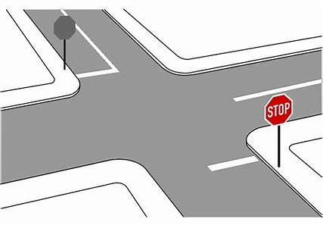

**________________ __________________ __________________ __________________**

1. **Classify the words:**

**nervous – Where – tired – How**

|  |  |
| --- | --- |
| **Feeling** | **Five W’s** |
|  |  |
|  |  |

1. **Circle the odd word:**
2. **Feeling :** sad – happy – driver – worried
3. **Match:**
4. witness a- someone who saw an event
5. insurance b- don’t get angry
6. injury c- payment for costs of an accident
7. don’t lose your cool d- where two roads cross

f- hurt from an accident

1. **Fill in the blank with the correct words in the box:**

**fortunately – busy – hurt – mess – accident**

1. Ali was injured badly in the …………………..
2. I was late, but ……………….. the meeting hadn’t started.
3. Lama cried because she had ………..…….. her knee.
4. I’m sorry, but I’m ………………… right now.
5. **Grammar:**
6. **Choose:**
7. There **(was – were – are)** a book on the desk.
8. There **(was – were – is)** two bikes in the garden.
9. **A: (Where – Why – What)** are you worried?

**B:** Because I have a test tomorrow.

1. **A:** Why are you absent yesterday?

**B: (So – Ago – Because)** I was sick.

1. They saw Reema in her room 10 minutes **(because – age – ago)**.
2. Do you have **(someone – nothing – anything)** to eat in the fridge?
3. I didn’t know about the meeting. **(No one – Nothing – Anything)** told me.
4. **A:** What do you want to drink?

**B:** **(Nothing – Someone – No one)**, I am not thirsty.

1. Yesterday I saw **(nothing – someone – anything)** playing with a ball in the park.
2. We stayed at home **(so – because – neither)** it was raining.
3. Farah was ill, **(so – because – neither)** she had to stay in bed.
4. **A:** I am a good student.

**B:** **(So – Neither – Because)** am I.

1. **A:** I am not scared.

**B: (So – Neither – Because)** am I.

1. **A:** I speak English.

**B:** **(So – Neither – Because)** do I.

1. **A:** I don’t speak Chinese.

**B: (So – Neither – Because)** do I.

1. **A:** I never speak French.

**B:** **(So – Neither – Because)** do I.

1. **Do as shown between brackets:**
2. There was a car in the garage.  **(Change into negative)**

…………………………………………………..

1. There were three books on the shelf.  **(Change into negative)**

…………………………………………………..

1. **(Complete the sentences with *so* or *because*)**
2. I am going to make a cake, …………. I need some eggs and flour.
3. She is going to stay at home …………….she has to study for an exam.
4. **(Show agreement with the statements. Use *so* or *neither*)**
5. I am happy today.

………………………………….

1. I eat fruit and vegetables.

………………………………….

1. I played football yesterday.

………………………………….

1. I am not hungry.

…………………………………

1. I don’t have a driver’s license.

…………………………………

1. I didn’t sleep early.

…………………………………