Name: …………………………………… Ms. Tahani ☺

Class: 1st Intermediate

**Revision Sheet _ Unit ( 7 ) : Where Do You Live?**

1. **Vocabulary:**
2. **Write the words under the pictures:**

**pharmacy – corner – swimming pool – bus stop – gym**

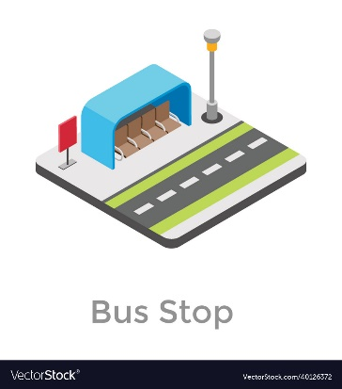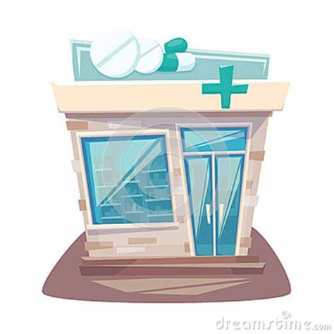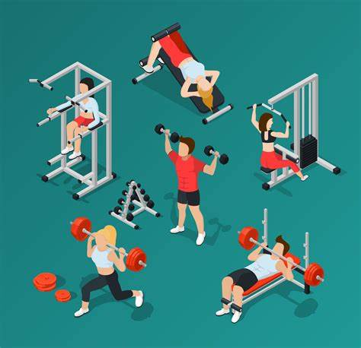

**________________ __________________ __________________ __________________**

1. **Classify the words:**

**bookstore – turn right – go straight – airport**

|  |  |
| --- | --- |
| **Places in neighborhood** | **Give directions** |
|  |  |
|  |  |

1. **Circle the odd word:**
2. **Places in neighborhood:** post office – bank – mall – curtains
3. **Give directions:** go up – sauna – turn left – go to the corner
4. **Match the opposites:**
5. left a- open
6. closed b- famous
7. different c- right
8. up. d- same

e- down

1. **Fill in the blank with the correct words in the box:**

**floor – convenience store – trust – get off – station**

1. Give me a call when you ……………………. the bus.
2. I looked for Layan and Lora at the bus ………………. .
3. Mayar lives on the second …………………... .
4. I am going to the ……………………... to buy some bread.
5. **Grammar:**
6. **Choose:**
7. I live **(in – on – at)** Dubia.
8. Huda lives **(in – on – at)** the fourth floor.
9. Nada lives **(in – on – at)** Main Street.
10. The bank is **(next to – near – between)** the pharmacy and the restaurant.
11. The bus stop is **(next to – on – between)** the corner.
12. Nora is **(tall – taller – tallest)**.
13. Jawaher is **(tall – taller – tallest)** than Dalia.
14. Bushra is the **(tall – taller – tallest)** student in the class.
15. Jeddah is **(modern – more modern – most modern).**
16. Jeddah is **(modern – more modern – most modern)** than Abha.
17. Riyadh is the **(modern – more modern – most modern)** city in KSA.
18. Ali’s mark is **(good – better – best)** than Hassan’s.
19. Dr Omar is the **(good – better – best)** doctor in the city.
20. **Do as shown between brackets:**
21. Planes are **(fast)** than cars.  **(Correct the mistake)**

…………………………………………………..

1. The ring is **(expensive)** than the necklace.  **(Correct the mistake)**

…………………………………………………..

1. Adel’s mark is **(bad)** than Ahmed’s. (**Correct the mistake)**

…………………………………………………..

1. Cheetah is the **(fast)** animal in the world. **(Correct the mistake)**

…………………………………………………..

1. A Ferrari is the **(expensive)** car. **(Correct the mistake)**

…………………………………………………..

1. That restaurant has **(bad)** food in the town.  **(Correct the mistake)**

…………………………………………………..

1. Shookh lives ……….. the tenth floor. **(Use *in* or *on*)**

…………………………………………………..

1. Rawan lives ………. Dammam.  **(Use *in* or *on*)**

…………………………………………………..

1. Amani lives ……….. Sari Street.  **(Use *in* or *on*)**

…………………………………………………..