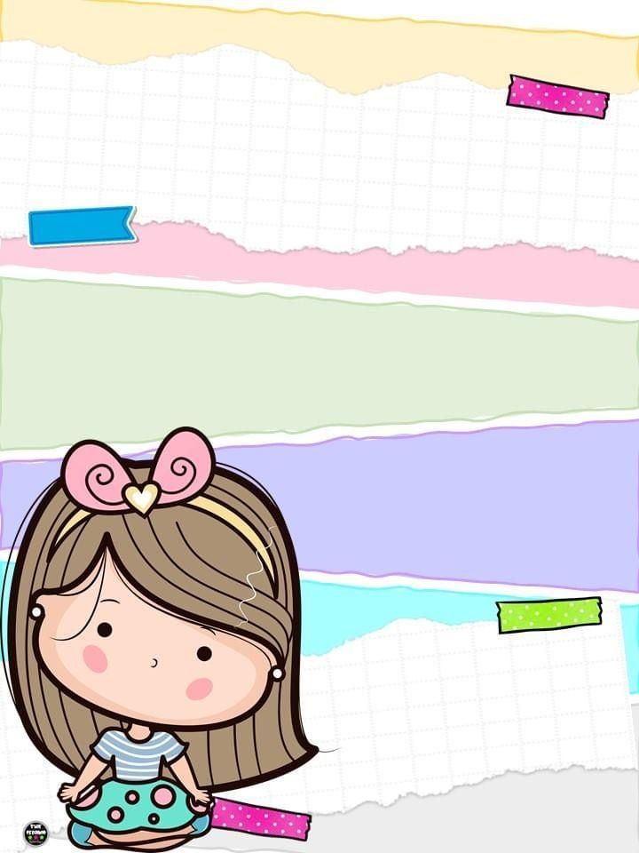

**English Booklet**

We Can

Second Term

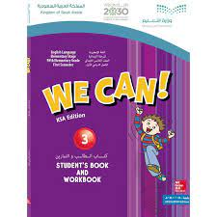

T. Taghrid Gazzaz

Your Name:……………………………….

**Yesterday and Today**

Unit 5

***Writing***

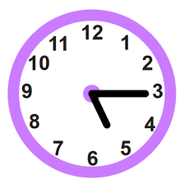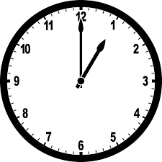***A-Write the time:***

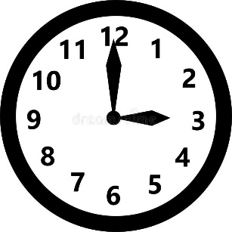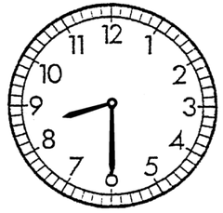

:

:

:

:



***B-Choose the correct answer:***

1-What time do you usually get up?

a-I usually get up at 5:00. B-It is a starfish.

2- What time did you come home yesterday?

a-I got up at 6:00. B- I came home at 12:00.

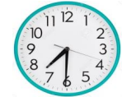3- What time it is?

a-It`s 7:30. B-It`s 11:45.

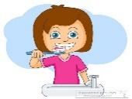***C****-* Unscramble: ***Rearrange the words to form a complete sentence:***

1. brush - I – teeth. – my

………………………………………………………………………………….

1. 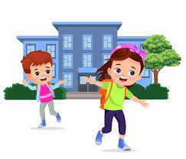finish – I – school.

…………………………………………………………………………………

***Reading:*** ***Write true √ or false X***



1- I eat my lunch. [ ]



b. He come home. [ ]



c. He took a bath. [ ]

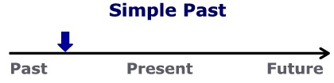***Grammer:***

***Choose the correct answer:***

1. I usually [ take – took ] a bath in the morning.

2. Yesterday, I [ do – did ] my homework after school

3. I usually [ eat - ate ] lunch at 3:30.

4. I finish school [ at – in ] one o’clock.

5. What time [ is – are ] it?

***Phonics:***

***Write (nk-ng-ck) to complete the word:***

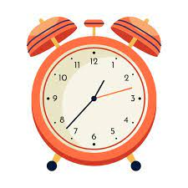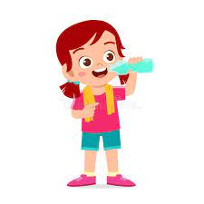

1. **Dri……….. 2- Clo……….**

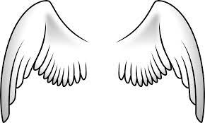

**3- Wi………. 4-Ri………..**

Jobs

Unit 6

***-Vocabulary:***

***Match and write the correct word under the picture:***

|  |  |  |  |  |  |
| --- | --- | --- | --- | --- | --- |
| Teacher | Astronaut | Cook | Diver | Firefighter | Three hundred |
| Doctor | Engineer | Pilot | Nurse | Businessman | One Thousand |

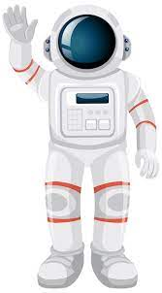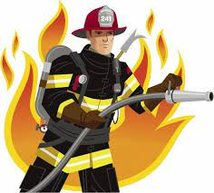







***Writing:***

1-What does your dad do?

A . I am playing. B . He is a businessman.

2 – What does the firefighter do?

1. He puts out fires. B. He flies plane.

3 – Do you want to learn many languages?

………………………………………………………………………………………………………………………….

***Reading: Write true √ or false X***

1.He is a pilot. ( )

2. She works at home. ( )



3-She is a reporter. ( )

***Grammer:***

***Choose the correct answer:***

1. (What-Who-Where) does she do? She is a doctor.
2. (What-Who-Where) is he? He is Faisal.
3. (What-Who-Where) does he work? He works in the fire station.
4. Amal works (on-under- in) the hospital.

***Phonics:***

***Write (gh-kn) to complete the word:***

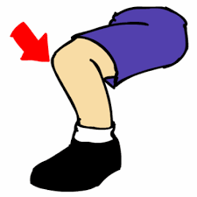

**1-……………ee 2-Ri………….t**

**3-……………ife 4-Li…………t**

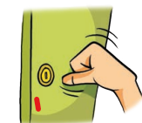

**5-………..ock**

**Fun on the Weekend**

Unit 7

***-Vocabulary:***

***Match and write the correct word under the picture:***

|  |  |  |  |  |
| --- | --- | --- | --- | --- |
| Cleaned | Watched | Cooked | Played | Studied |

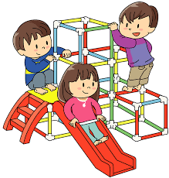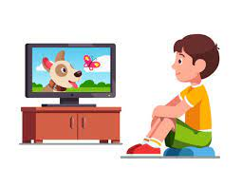

***Writing:***

What did you do over the weekend?

A- I a played football. B- I am an astronaut.

Unscramble: ***Rearrange the words to form a complete sentence:***

1- practiced - He – on the trampoline.

……………………………………………………………………………………………

1. home. – stayed - Noura

…………………………………………………………………………………………….

***Reading:***

 ***Read the sentences and match them with the correct picture:***

1. They played outside over the weekend.
2. Fatimah cooked dinner last night.
3. Imad watched TV for three hours last night.

***Grammer:***

***Choose the correct answer:***

1. Last night, he (kikes-kicked) a ball three times.
2. On the weekend, Fahad (studies-studied) for six hours.
3. How (much-many) apples do you have?
4. How (much-many) flour do you need?
5. We have (some-any) sugar, but we don‘t have (some-any) milk.

***Change the verb to the past simple tense:***

images1-clean🡪 …………………… 2- play 🡪…………………. 3- watch 🡪…………......

***Phonics:***

***Write (nd-nt) to complete the word:***

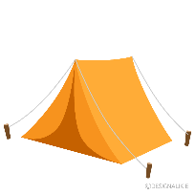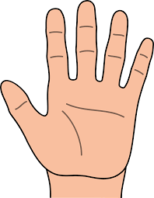

1. **Ha…….. 2- Te…………**



**3-Pla……… 4- Sa………….**

**Life’s Ups and Downs**

Unit 8

***-Vocabulary:***

***Match and write the correct word under the picture:***

|  |  |  |
| --- | --- | --- |
| Congratulations | Sorry about that. | How scary! ! |

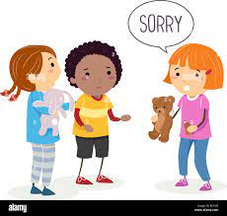 

***Grammer:***

***Choose the correct (past tense verb):***

What good ⁄ bad things happened to you last week?

1-We (has -had) a cake.

2-I (get-got) first place in a race.

3-I (see- saw) a rainbow.

***Change the verb to the past simple tense:***

1-win 🡪 …………….. 2-lose 🡪 ………………… 3-make 🡪 …………………

***Reading: Read the passage and answer the questions:***

A Fun Day

Yesterday, we went to an adventure park. Our father drove us there. My sister and I saw some friends from school and played with them. Then we went on rides with our parents. It was great fun! After the rides, Dad got me a burger. My sister didn’t ‘t want one, so he got her an ice cream. We were good, so Dad promised to take us again next week. I can ‘t wait!

1-Where did they go? They went to the ………………..

1. adventure park b-school

2-Who drove them to the place? Their ……………….. drove them there.

1. teacher b-father

3-Their Dad promised to take Them again next……………

a- week. b- month

His sister didn’t ‘t want burger, so he got her an …………..

a-apple b-ice cream.

***Phonics:***

***Write (ph- f- gh) to complete the word:*** 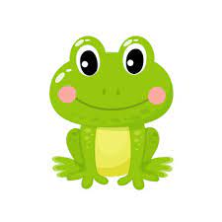

1. 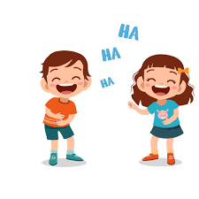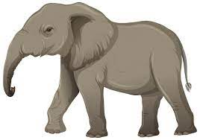**……….one 2- ……….rog**

 **3- lau……….. 4*-* ele ……. ant**

**5-…………riend**

|  |  |  |  |
| --- | --- | --- | --- |
| **نتيجة بحث الصور عن ‪sad face clipart black and white‬‏Not achieved** | **Achieved** | **1st Month** |  |
|  |  | **Picture dictionary**  **ابحث عن صور لها علاقة بالكلمات وأجمعها في ورقة** | **1** |
|  |  | **Answer the practice book.**  **حل كتاب تمارين** | **2** |
|  |  | **Copying**  **نسخ في دفتر الطالبة** | **3** |
|  |  | **Worksheets**  **أوراق عمل** | **4** |
|  |  | **Keep your notebook clean and organized.**  **حافظي على دفترك نظيفاً ومرتباً.** | **5** |
|  |  | **Respect your teacher and your friends, keep your class clean .**  **أحترم معلمتي وصديقاتي، وأحافظ على نظافة فصلي.** | **6** |
|  |  | **Try to practice reading and speaking skills.**  **أحاول التدرب على القراءة والمحادثة بالإنجليزية** | **7** |

|  |  |  |  |
| --- | --- | --- | --- |
| **نتيجة بحث الصور عن ‪sad face clipart black and white‬‏Not achieved** | **Achieved** | **2nd Month** |  |
|  |  | **Picture dictionary**  **ابحث عن صور لها علاقة بالكلمات وأجمعها في ورقة** | **1** |
|  |  | **Answer the practice book.**  **حل كتاب تمارين** | **2** |
|  |  | **Copying**  **نسخ في دفتر الطالبة** | **3** |
|  |  | **Worksheets**  **أوراق عمل** | **4** |
|  |  | **Keep your notebook clean and organized.**  **حافظي على دفترك نظيفاً ومرتباً.** | **5** |
|  |  | **Respect your teacher and your friends, keep your class clean .**  **أحترم معلمتي وصديقاتي، وأحافظ على نظافة فصلي.** | **6** |
|  |  | **Try to practice reading and speaking skills.**  **أحاول التدرب على القراءة والمحادثة بالإنجليزية** | **7** |

