Name :………………………………….……………..…………………………. Class :……………………………………

Midterm Exam

* **Write the time:**

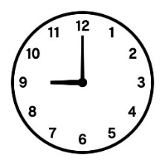

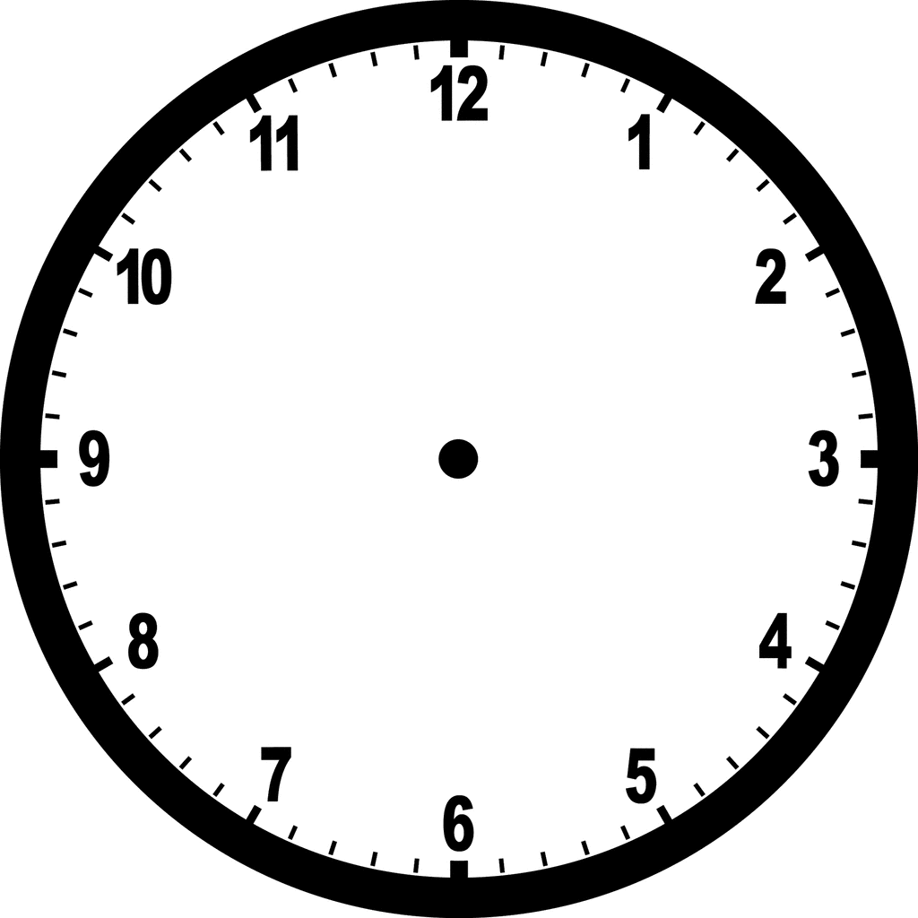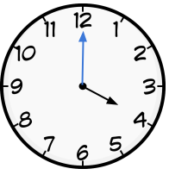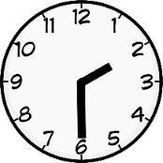

**:**

**:**

**30 : 7**

**00 : 5**

**:**

* **Read and put ( ✓ ) or ( 🗶 ) :**

1- a cook works in restaurant ( )

2- a pilot works in an airplane ( )

3- She is a doctor ( )

4- He is a businessman ( )

* **Choose the correct answer:**

1- Yesterday I ( eat lunch – ate lunch ) at 4:00 .

2- I usually ( get up – got up ) at 6:00 .

3- Yesterday I ( come home – came home ) at 8:00 .

4- I usually ( take – took ) a bath .

5- I finish school ( at – in ) 1:00

* **Choose the correct sound ::**

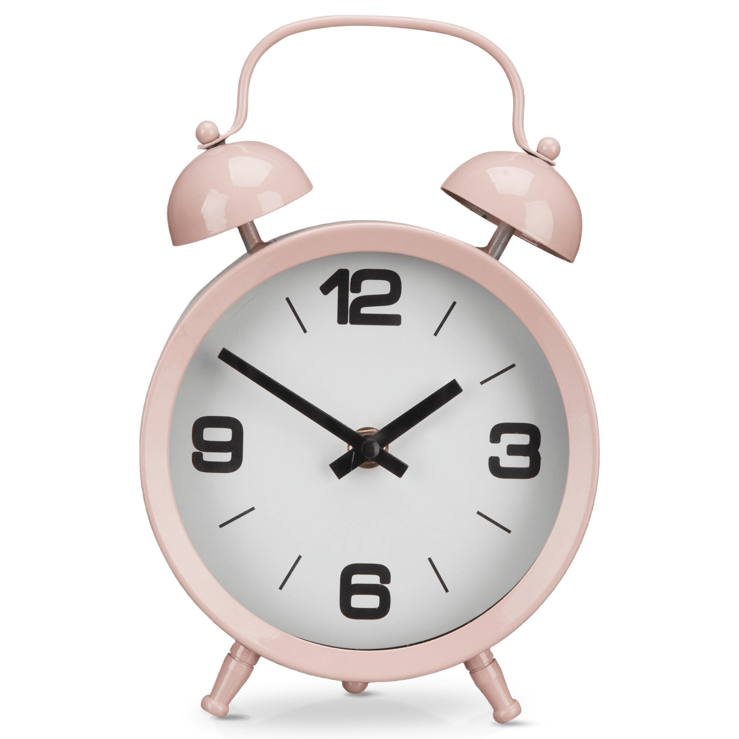

…….ife

gh

kn

gh

kn

gh

li…..t

nk

ng

ng

ng

kn

ni……t

ri…….

ck

dri…….

Clo…….

nk

**Your teacher:** Alia Al-Qahtani