|  |  |  |  |
| --- | --- | --- | --- |
| **متفوق** | **متقدم** | **متمكن** | **غير مجتاز** |
|  |  |  |  |

**رقم المهارة**

**التقييم**

**9**

|  |
| --- |
| Pencil Drawing - How To Draw A Pencil Step By Step**1 – What is this?**  **A** .  **It's a pencil .**  **B** . **It's a book .** |
| **2- How old are you ?**  **A** .  **I am 10 .**  **B** . **I am Ali.** |

**التقييم**

**رقم المهارة**

|  |  |  |  |
| --- | --- | --- | --- |
| **متفوق** | **متقدم** | **متمكن** | **غير مجتاز** |
|  |  |  |  |

25 , 15

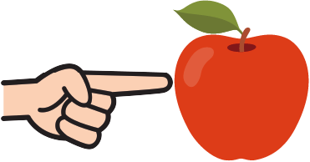

|  |  |  |
| --- | --- | --- |
| **1.This is an apple .** | 🗸 | 🗴 |
| **2 – It is black.** | 🗸 | 🗴 |

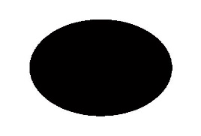

_____________________________________________________________________________________________________________________________________________________________________________________________________

**التقييم**

**رقم المهارة**

|  |  |  |  |
| --- | --- | --- | --- |
| **متفوق** | **متقدم** | **متمكن** | **غير مجتاز** |
|  |  |  |  |

10

**Choose ( a / an / this / that ):**

|  |
| --- |
| This is ___ apple . |
| That is ___ book . |
| ______ is a pencil |



|  |  |  |  |
| --- | --- | --- | --- |
| **متفوق** | **متقدم** | **متمكن** | **غير مجتاز** |
|  |  |  |  |

31 **,** 1

**التقييم**

**رقم المهارة**

**read and complete the letters:**

|  |  |
| --- | --- |
|  | **A** |
|  | **B** |

|  |  |
| --- | --- |
| **c** |  |
| **d** |  |

|  |  |
| --- | --- |
|  | **E** |
| **f** |  |

**Rewrite the letters**

-------------------------------------------------------------------------------------------------------------------------------------------------------------------------------------------------------------------------------------------------------------------------------------------------------------------------------------------------------------------------------------------------------------------------------------------------------------------------------------

**_____________________________________________________________________________________________________________________________________________________________________________________________**

**رقم المهارة**

**28 ,29 , 30 , 32**

|  |  |  |  |
| --- | --- | --- | --- |
| **متفوق** | **متقدم** | **متمكن** | **غير مجتاز** |
|  |  |  |  |

**التقييم**

**What color are they?**

------------------------------------------------------------------------------------------------------------------------------------------------------------------------------------------------------------------------------------------------------------

------------------------------------------------------------------------------------------------------------------------------------------------------------------------------------------------------------------------------------------------------------

_______________________________________________________________________________________________________________________________________________________________________________________________________

**التقييم**

|  |  |  |  |
| --- | --- | --- | --- |
| **متفوق** | **متقدم** | **متمكن** | **غير مجتاز** |
|  |  |  |  |

**رقم المهارة**

**5**

**Listen to the word and match with letters :**

|  |  |  |  |
| --- | --- | --- | --- |
| **h** | **j** | **g** | Goat Standing Isolated On White Background Female Goat Animal Isolated  Stock Photo - Download Image Now - iStock  **1 –** |
| **d** | **c** | **f** | Mallard Duck  **2-** |
| **f** | **g** | **d** | How To Draw A Fish - Step By Step Instructions - Busy Little Kiddies  **2-** |

_____________________________________________________________________________________________________________________________________________________________________________________________________

|  |  |  |
| --- | --- | --- |
| 53+ Thousand Cartoon Goat Royalty-Free Images, Stock Photos & Pictures |  Shutterstock | PEN definition and meaning | Collins English Dictionary | 37,900+ Eraser Stock Illustrations, Royalty-Free Vector Graphics & Clip Art  - iStock | Pencil eraser, Chalkboard eraser, Pink eraser |
| Camel | Book | Eraser |
| goat | pen | hat |

|  |  |  |  |
| --- | --- | --- | --- |
| **متفوق** | **متقدم** | **متمكن** | **غير مجتاز** |
|  |  |  |  |

**التقييم**

**24**

**رقم المهارة**

______________________________________________________

**التقييم**

**رقم المهارة**

|  |  |  |  |
| --- | --- | --- | --- |
| **متفوق** | **متقدم** | **متمكن** | **غير مجتاز** |
|  |  |  |  |

**26**

**Listen then write the missing letter:**

|  |
| --- |
| Varieties Archive - New York Apple Association  **1 – __pple** Varieties Archive - New York Apple Association |
| Bart the Bear II, featured in countless films and TV shows, dies | CNN  **2- __ear** |
| COW definition and meaning | Collins English Dictionary  **2- __ow** |

___________________________________________________________

Good luck T.

Controlled writing

|  |  |
| --- | --- |
| المهارة / رقمها | ترجمتها |
| Ask and respond to basic questions about personal information Using verb to be (am, is, are), and wh. questions (what, where, who), how)  9 | **يسأل ويجيب باستخدام ( (IS , AM , ARE**  **وباستخدام انواع الاسئلة**  **( من – ماذا – اين – كيف )** |
| Read and comprehend simple short sentences  25 | **قراءة الجمل القصيرة واستيعابها** |
| Write upper / lower case letters correctly  31 | **كتابة الحروف الكبيرة / الصغيرة بشكل صحيح** |
| Recognize and produce the sounds of the English alphabet  1 | **التعرف على أصوات الحروف وقرائتها** |
| Recognize and apply directionality in writing English  28 | **معرفة وتطبيق الاتجاه المناسب عند الكتابة باللغة الانجليزية _ (من اليسار لليمين , أعلى , أسفل )** |
| Use lined paper correctly with headline, midline, and baseline  29 | **استخدام الورق المسطر والكتابة علية بشكل صحيح** |
| Copy words , numbers and simple short sentences .  30 | **نسخ الكلمات والأرقام والجمل القصيرة البسيطة** |
| Use appropriate spacing between words  And sentences.  31 | **استخدام المسافات المناسبة بين الكلمات والجمل عند الكتابة .** |
| Recognize and match sounds to letters  5 | **التعرف على الأصوات ومطابقتها مع الحروف** |
| Read and match words to photos.  24 | **قراءة ومطابقة الكلمات مع الصور.** |
| Spell some simple sight words correctly.  26 | **تهجئة بعض الكلمات بشكل صحيح وكتابة الحرف الناقص .** |
| Recognize and use indefinite articles (a, an) using (this and that)  10 | **يتعرف ويستخدم أدوات التنكير (أ، أن) باستخدام**  **(هذا وذاك)** |
| Identify main colors (red, blue, green, black, white, yellow, brown) | **تحديد الألوان الرئيسية (الأحمر، الأزرق، الأخضر، الأسود، الأبيض، الأصفر، البني)** |

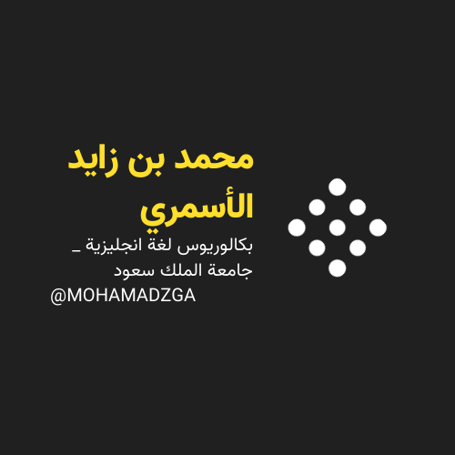

**لا تنسوني من صالح دعائكم**





M_zaid0