**مراجعة الوحدة السادسة / السابعة للصف الأول متوسط**

**الاسم:** ________________________ **الفصل:** __________________

**Q.1) – Reading Comprehension**

Read the following paragraph then answer the questions:

My name is Smith. I am the father of three kids. Me and my wife have decided to move into a new house. Why do we want to leave our old house? because it is too small for us to live in it! It has only one bedroom, a bathroom, and a kitchen. We don't even have a living room. The new house is bigger and better than our old house. The new house has two bedrooms, a bathroom, a kitchen, a living room, and a garden too! The kids will love the garden; it is beautiful and full of trees and flowers.

A ) – Choose the correct answers:

|  |  |  |
| --- | --- | --- |
| 1. Smith is the father of …………….. kids. | | |
| A ) - two | B ) – three | C ) - four |
| 2. The Smith's family have decided to move into a new …………………. | | |
| A ) - city | B ) - house | C ) - car |
| 3. The kids will love the …………………; it is beautiful and full of trees and flowers. | | |
| A ) – living room | B ) - garden | C ) – kitchen |

B ) – Put ( T ) for true and ( F ) for false sentences:

1. The Smith's family don't have a living room in the new house. ( )

2. The Smith's family want to leave their old house because it is too big. ( )

**Q.2) – Grammar**

A ) – Choose the correct answers:

1. Ahmad is ( tall – taller – the tallest ) than Fahad.

2. I can speak English, ( and – but – or ) I can't speak French.

3. ( There are – There is – There have ) an apple on the table.

4. I am ( old – older – the oldest ) than my brother.

5. My sister lives ( at – in – on ) Jeddah.

6. This restaurant has ( good – better – the best ) pizza in town.

7. Do you want coffee ( but – and – or ) tea?

B ) – Fill in the blanks with the correct prepositions:

( between – in – behind – under – next to )

|  |  |
| --- | --- |
| 1. The boy is ……………………….. the books. | behind preposition of place - Clip Art Library |
| 2. The elephant is …………………… the chair. | prepositions | Baamboozle - Baamboozle | The Most Fun Classroom Games! |
| 3. The apple is ………………………. The boxes. |  |
| 4. The boy is ………………….. the box. | Oy In Box Clip Art - Inside The Box Clipart Black And White - Free  Transparent PNG Clipart Images Download |
| 5. The ball is …………………….. the table. | ball under the table drawing - Clip Art Library |

C ) – Put the following imperatives of direction under the correct pictures:

( Turn right – Turn left – Go straight )

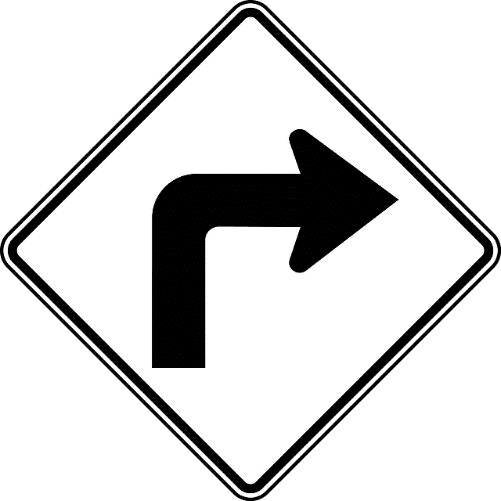

……………………………………. …………………………………………. …………………………………

**Q.3) – Vocabulary**

A ) – Put the following words under the correct category:

( refrigerator – stove – bathtub – shower – flowers – trees – toilet )

|  |  |  |
| --- | --- | --- |
| Kitchen | Bathroom | Garden |
|  |  |  |

B ) – Put the following words under the correct pictures:

(Bedroom – Kitchen – bathroom)

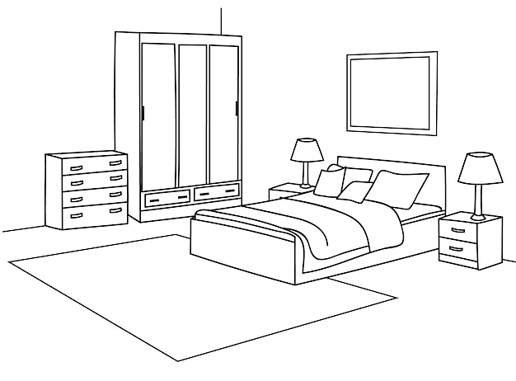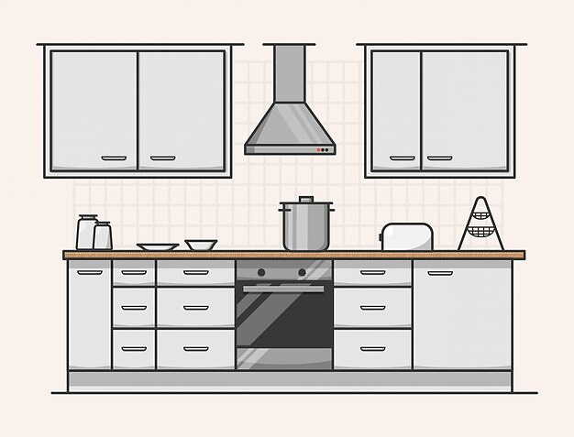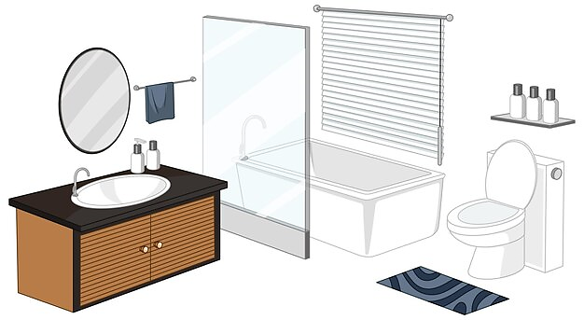

………………………………………. ………………………………………………… ……………………………………..

C ) – Match the words with their meanings:

|  |  |  |
| --- | --- | --- |
| 1. Trust me |  | A ) – you are sure to see it. |
| 2. restaurant |  | B ) – believe me. |
| 3. you can't miss it |  | C ) – a place to eat. |

**Q.4) – Spelling**

A ) – Choose the correct missing letter:

1. Most kitchens have a "microwa__e". ( v – s – t )

2. an "arm__hair" is found in the living room. ( c – f – d )

3. a "Mirr__r" can be found in the bathroom. ( o – b – z )

**Study Hard. Good Luck 😊**