30 | 3ed intermediate stage  Final exam, 3ed semester  Time / 1.5 hours |   1446  ثاني متوسط  الدور الأول | THE MINISTRY OF EDUCATION  ________ DIRECTORATE EDUCATIONAL  ________INTERMEDIATE SCHOOL
إسم الطالب :................................................................................ |  |  | رقم الجلوس: .......................
Student’s Mark Written /

Comprehension

Q1: Read the passage then answer the questions:

The Custodian of the Two Holy Mosques, King Salman bin Abdulaziz was born in Riyadh on December 31, 1935. He was educated at the Princes’ School in Riyadh where he studied sciences, religion, and the Holy Qur’an. He was appointed Crown Prince of the Kingdom of Saudi Arabia and Deputy Prime Minister by his predecessor, King Abdullah bin Abdulaziz, on June 18, 2012. Crown Prince Salman became the King of Saudi Arabia and the Custodian of the Two Holy Mosques on January 23, 2015.

6

- Put ( √ ) or ( X ):

• King Salman bin Abdulaziz was born in Riyadh ( )
• King Salman bin Abdulaziz was born on December 13, 1935. ( )

- Choose the right answer:

• He was educated at the Princes’ School in ( Taif - Riyadh - Abha ) .
• He was appointed Crown Prince of Saudi Arabia ( on – in – was ) June 18, 2012 .

- Complete:
• where he studied …………………….., religion, and the …………………………… Qur’an.
Grammar

Q1: Choose the right answer:

7
- He’s studied English ( for - since - while ) third grade.
- Buses are ( most - is - less ) expensive than taxis.
- You’re from Riyadh, aren’t you? ( no - Yes - Not ), I am.
Q2: Complete sentences with correct words:

Could - Can - was - on

- .………………………… you help me? Sure. No problem.
- The telephone ……………………. invented by Alexander Graham Bell.
- He is in Dubai …………………………………………….. business.
Q3: Correct :
Suddenly I hear someone call my name. ………………………………………………………….…………………………….……………………….
1

Vocabulary

7
Q1: Write word under the right picture:
Police officer - Credit Card - An antique - Plane - Seat belt
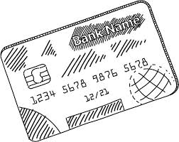 | 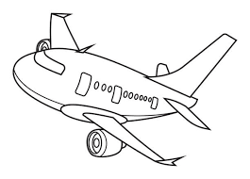 | 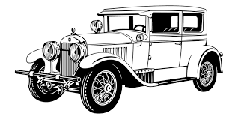 | 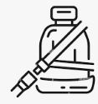
……………………..……..…….. | ……………………..……..…….. | ……………………..……..…….. | ……………………..……..……..

Q2: Write word’s number in left in front of suitable word in right :

1. steering ( ) a child who has lost his parents a little.
2. orphan ( ) wheel.

Q3 : Reorder :
Inventions - changed - people’s lives. ……………………..…………….………………………………………………..……..
Spelling

Q1: write the missing letters :

4

o - b - a - w - a

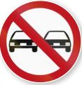 | 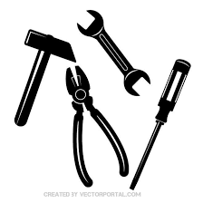 | • I’ve never been rock clim ___ ing.  • Jeddah one of the best pl___ces to live in the Middle East.
• No Pa ___ sing. | •___ools.

Composition

Q1: Write a paragraph about events in your town no less than 50 words, use the following words and phrases:

6

What? – Where? – When? - Who? - Why? - How? - Witness

................................................................................................................................................................................................................................................
................................................................................................................................................................................................................................................
................................................................................................................................................................................................................................................
................................................................................................................................................................................................................................................
................................................................................................................................................................................................................................................
Good luck
2

