

**الابتدائية :**

**الاسم :......................................**

**الفصل : ...... / .....**

**المملكة العربية السعودية.**

**وزارة التعليم.**

**مكتب تعليم**

اختبار الفترة الاولى مادة اللغة الإنجليزية الصف الثالث الترم الثاني لعام1444-

25

1 – Listen and circle the correct picture:

|  |
| --- |
| **1 - It is cold.** |
| **2 – It is small and quiet.** |
| **3 – It is winter.** |

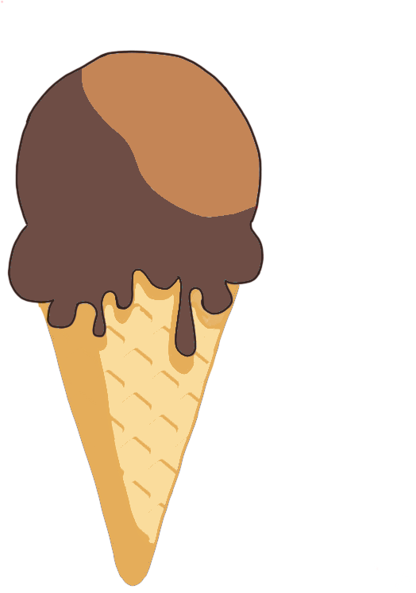



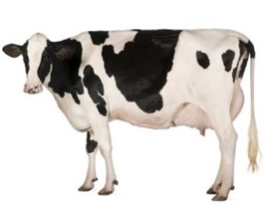

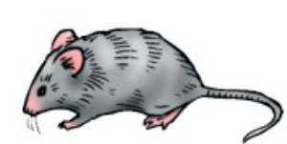

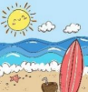

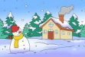

2 – Choose the correct answer :

|  |
| --- |
| **1 - Apples are……….. ( sweet - sour )** |
| **2 – Whose book is that? It is ………………… ( Nawal - Nawal's )** |
| **3 – It is a ……… (flower - star )** |
| **4 - Do you have sandwiches? ( Yes, I do. - I’m ten. )** |
| **5 – It is ……………………... ( short - long )** |



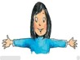

3 – Complete the missing :

**January - fall**

|  |  |  |  |
| --- | --- | --- | --- |
| ………….. | summer | spring | winter |

|  |  |  |
| --- | --- | --- |
| March | February | ………………….. |

4 – Read and put **🗸 or 🗴**  :

|  |  |  |
| --- | --- | --- |
| **1. Lemons are sour.** | 🗸 | 🗴 |
| **2. Snake is short.** | 🗸 | 🗴 |
| **3. It is a goat.** | 🗸 | 🗴 |

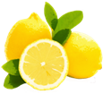



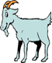

5 – Read and choose the correct answer:

|  |  |  |
| --- | --- | --- |
| is | am | **1 – Ali …… talking.** |
| When | Whose | **2 – ……………hat is this?** |
| or | but | **3 – Is it sweet …. sour?** |

6 – Write the correct word under each picture:

|  |  |  |  |
| --- | --- | --- | --- |
|  |  |  |  |
| ………………….. | ………………….. | ………………….. | ………………….. |

strong - soup - plastic bag – chips

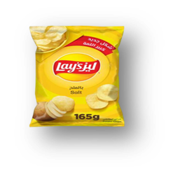

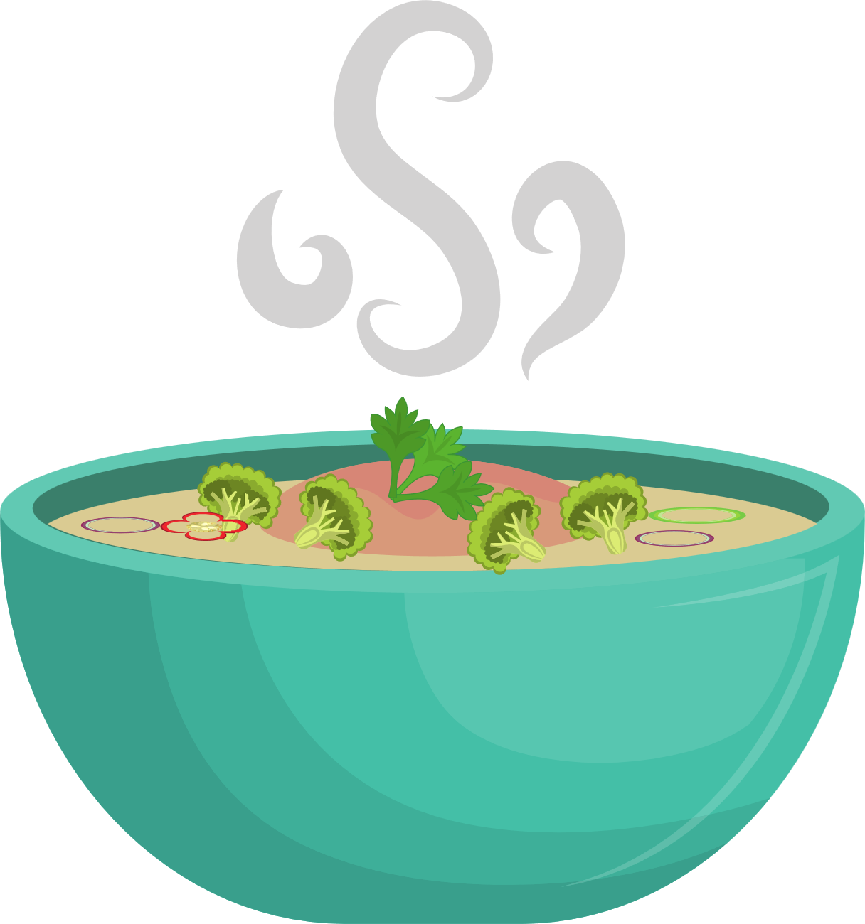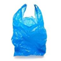

7 – Choose the correct letter:

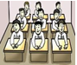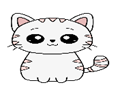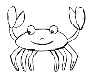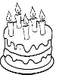

|  |  |  |  |  |
| --- | --- | --- | --- | --- |
|  |  |  |  |  |
| **__ass**  **( gr - cI )** | **ca__**  **( h - t )** | **__ab c**  **( r - n )** | **__ ake**  **( g - c )** | **__ass**  **( sh - gl )** |