**I – Listening :**

**A- Choose: 4 Marks**

**1- The robbery happened about ……………………………………**

a- half past three b- three o'clock **½**  c- five thirty d- one o'clock

**2- The man with dark hair was about ………………….years old.**

a- Twenty**½**  b- Twenty eight c-thirty d- ten

**3- …………………….went into the kitchen.**

a- the short man b-both men c-the tall man**½**  d-none

**4- she lost …………………………dollars.**

a-50**½**  b-150 c- 5 d-15

**B- True √ or False ×:**

1-They said 'they from water company. ( **True √**  ) **½**

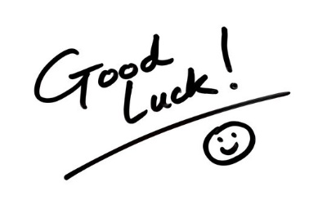2- The blond man about fourteen . ( **False ×** ) **½**

3-They took the woman's wallet . ( **True √**  ) **½**

4-She didn’t ask them about their identification. ( **False** ) **½**

**End**