**Choose the correct answer :**

1-I want to buy a phone, (and - but – or – so ) I don’t have enough money

2-If you ( wake up - wakes up – woke up – waking up) late , you will miss the bus

3-Sara didn't' eat breakfast or lunch. She (can't – must – might – can) be hungry now.

4-I (can – could – may – might) run 10 miles when I was young.

5-He has lived in Dammam (for - since – ago – yet) 1999.

6-I should have (call -calls – called- calling) you earlier, But I didn’t.

**Correct the mistakes :**

1-If I had (study) ……………………………………hard, I might have passed the exam

2-I didn't ( needed to ) …………………………………….wait, she was just on time

**Fill in the spaces with suitable words :**

(serve – crashed – invented )

1-The Sumerians……………………………………………. the wheel in 5000 B.C.E.

2-The Kingdom is honored to welcome and …………………………………an increasing number of pilgrims

**Match the words with their opposite:**

|  |  |  |
| --- | --- | --- |
| light | )) | 1-advantage |
| disadvatage | )) | 2-heavy |
| Ordinary-normal | )) | 3-weird |
| unemployed | )) | 4-employed  5-upgrade |

1

Choose the correct meanings :

**1-Beats me**

a)Anything is bossible b)help me c) I have no idea d) excuseme

**2-Remote**

a) far away b)near c)quick d)book

**3-breathing under someone's neck**

a)leave b)constantly checking c)love d)admire

**4-Rural**

a)dynamic b)business c)modern d)of or relating to the country

Ask for a permission :

Go to bathroom

………………………………………………….?

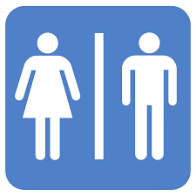

**Bonus question**

**+1**

2

Good luck

Tr: Kholoud AlGhamdi