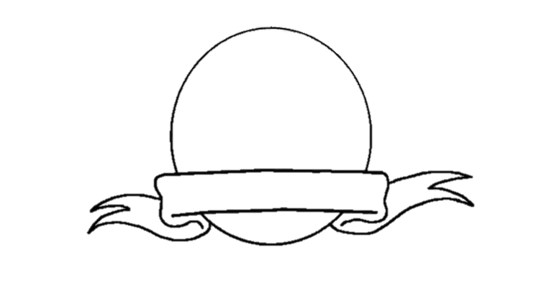

**Conditional Sentences: Hypothetical Situations in the Past**

**Venn**

**Diagram**